**Section 7 done: 29/29 Diving Deeper into Components & React Internals  
Better Project Structure**  
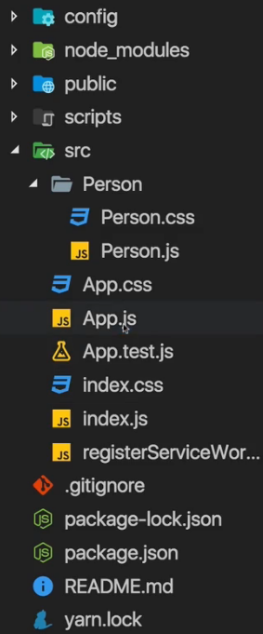

* There’s nothing wrong with our 2 component but behind the scenes we can still tweak this a little bit.  
=> For example you would typically split this application in more components than that.  
=> The question always is - what should go into its own component and what do you group together in a higher component, in the root component for example.  
* Now if we analyze our existing components, we see that the Person component is pretty focused, it displays the card of one person, the information of one person, it handles a click on that card. So this component doesn’t need any more splitting up. What would you put into its own component? You could outsource the input into its own component, that might make sense if you want to create a generic input component across your application where you really only change the styling but if that’s not the goal, putting input into its own component doesn’t make much sense. And the same for paragraphs - if you want to create some custom paragraph wrapper component which gives all your paragraphs some specific styling and behavior, if it’s only about the global styling though, use the global stylesheet - the index.css file.   
* We can split up our App.js though - we manage the state and do quite a lot of things there.  
* Now typically container components like the App.js component (so those who manage state) shouldn’t be involved with the UI rendering too much. Their render method should be rather lean and contain not too much JSX.  
=> For example it might make sense to create a Person list component or a Persons component is how we could name it. We could then simply pass this array of persons into this component and inside that we would do that mapping and render the list.  
=> Another improvement is we could outsource our cockpit into its own component. So that in the end our App.js component really only has this wrapping div and then a cockpit component and a persons component. This is of course optional but it’s a good practice since it’ll make our App.js component more focused and gives us these other components which also have a clear focus.  
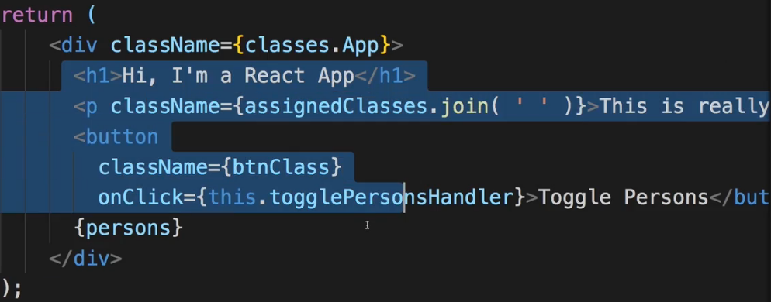  
* We create a Persons folder for it, move the Person folder into it and create Persons.js.  
* We can improve the structure even more - in our `src` folder we might also add things like an `assets` folder which contains `images` or stuff like that. So it might make sense to create a `components` folder in the `src` folder, which holds all of our components.  
* We also might have a `containers` folder in the `src` folder - which holds all our containers like the App.js and its respective CSS file. Also move the testing file there.  
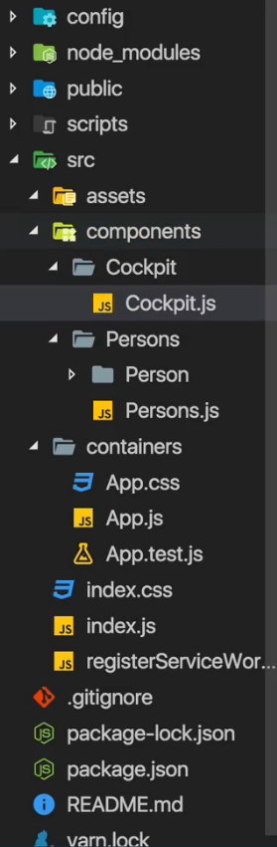  
=> The goal now is to fix the imports to fit the new project structure.  
**Splitting an App Into Components**  
* If we only want to return something in that function body of a functional component, due to our project setup and all the ES6+ features we can use, we can shorten this to just return () parenthesis. If you only have 1 line in an arrow function (you can use the parenthesis) it automatically returns. Now in here, you directly put your JSX code.  
* We need to adjust the persons to props.persons and also the methods - no longer this.method but passed as props.  
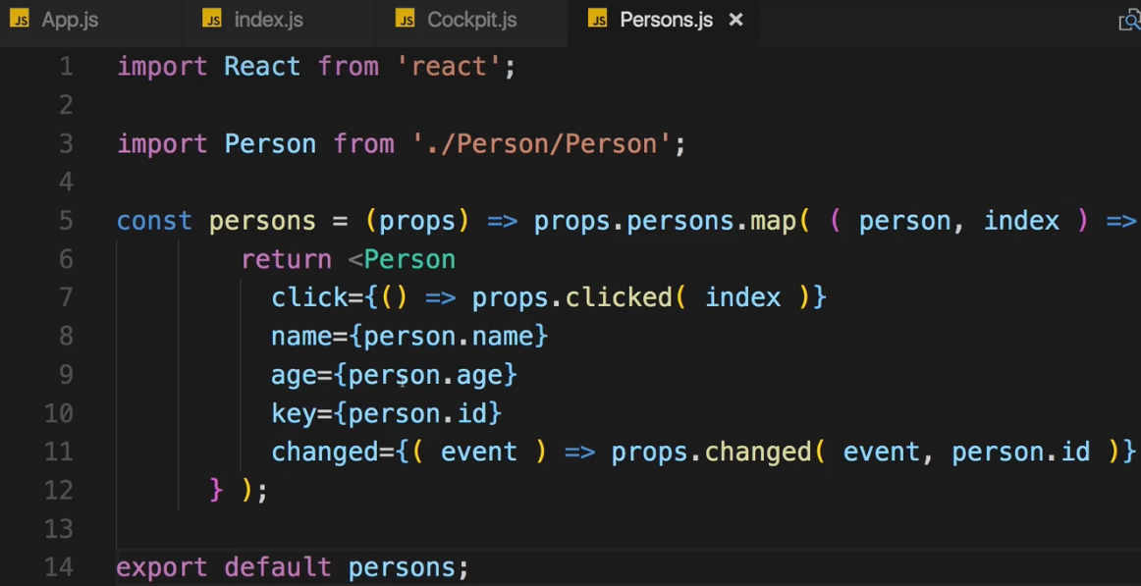 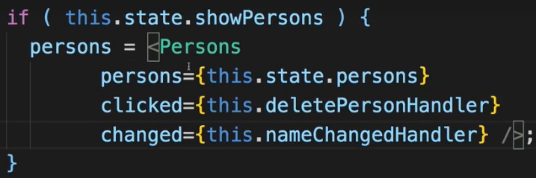  
=> We don’t need the wrapping div around Persons because it’s just 1 element.  
=> Now in the App.js container we don’t have to worry about the logic of creating that list, we outsource this to be a Persons.js file and it is the best practice to create granular pieces where each component has a clear focus.  
* Now the same goes for the Cockpit.js. We want to put this into its own component.  
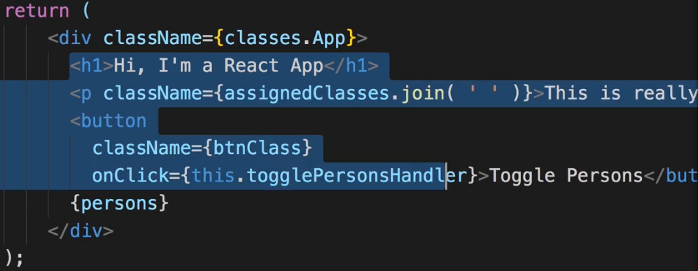  
* We need to wrap it with a div - later we’ll see how to do it without a div.  
* We already did it once - for the list - that is supported in React 16.  
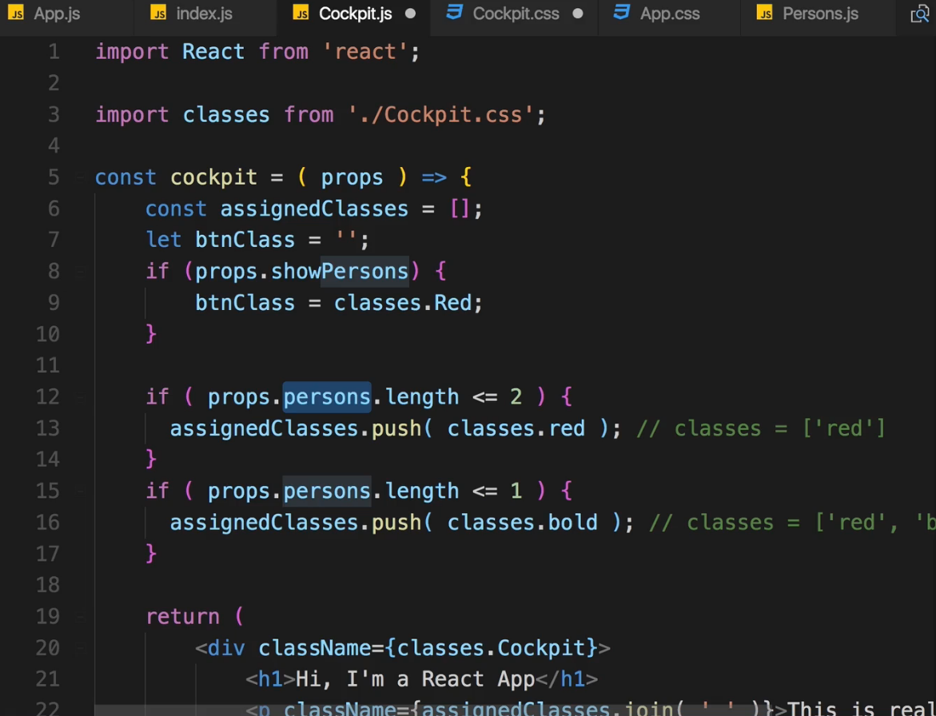  
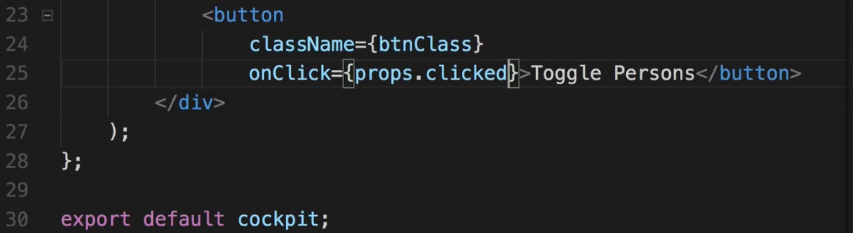  
=> In App.js.  
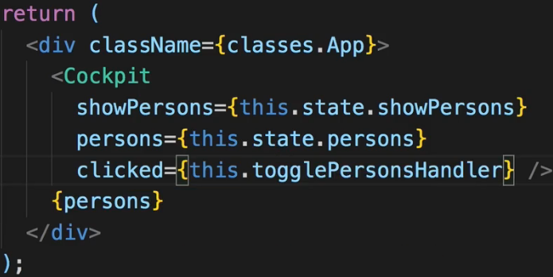  
* Beyond these we only got our handlers - functions here which manipulate the state and that’s exactly the idea behind such a container - it manages the state and it manipulates the state.  
* You should have clear responsiblities of your components, have them narrowly focused, create granular components, use as many functional components as possible and have our containers as lean as possible. When it comes to JSX and styling some containers might not even have a style file because they only import other components which then do this styling.  
**Comparing Stateless and Stateful Components**  
* Why creating Stateless Components as often as possible?   
=> They have a narrow focus and a clear responsibility, they are only about presenting something.  
=> They are about rending some JSX.  
=> And they contain some logic to display this JSX correctly. For example adding CSS classes.   
=> They don’t do much else and they can’t manage state.  
* We wanna have a few places in our application where the application state does change, this makes sure your application stays maintainable even as it grows. Because the more your application grows, the harder it becomes to manage state because if you manage state in every single component, it is super hard to track where you edited this list of persons, where you created this new post.  
* If you got a central point in your application and a good split - typical are multiple features, so for example if you have a blog feature and authentication feature in your app, then the root components of these features might very well be containers which manage the state for that feature area.  
* **There is 1 important difference besides the existence of state and the availability of methods - and that is the** **Lifecycle of a Component / Lifecycle Hooks**.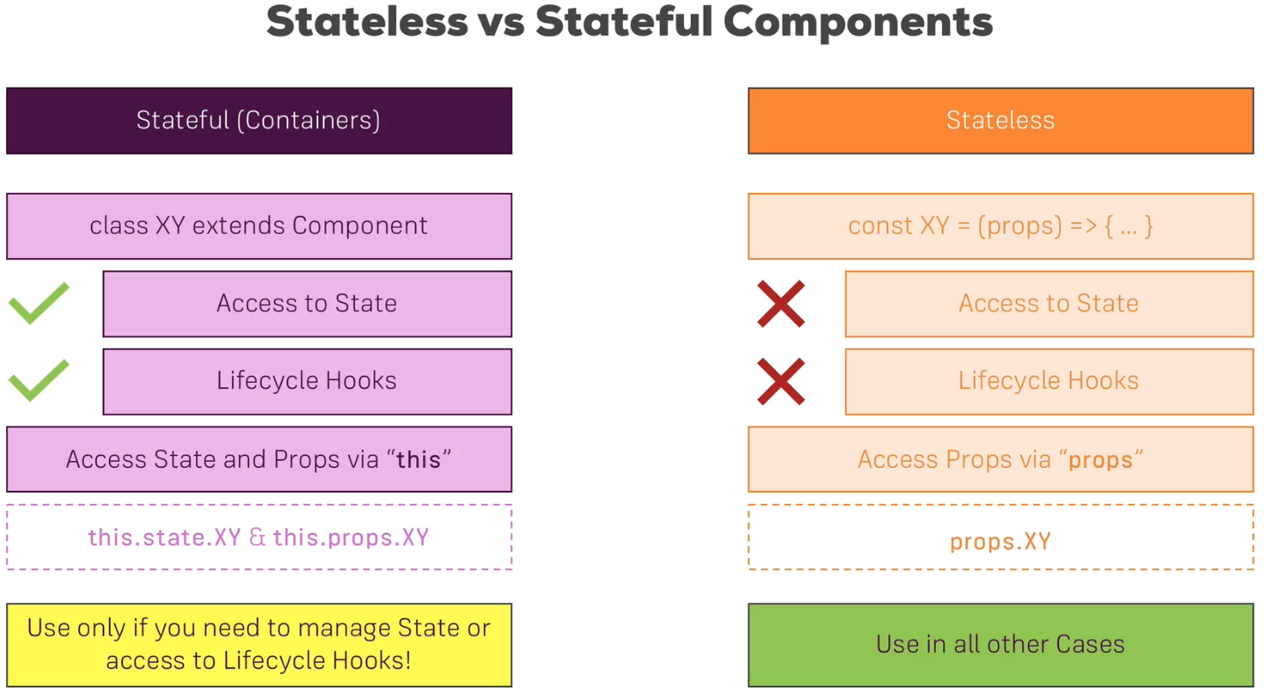  
* Our container App.js doesn’t use props but it would have access to props too. Let’s see how.  
* Let’s pass some props right from the index.js file.  
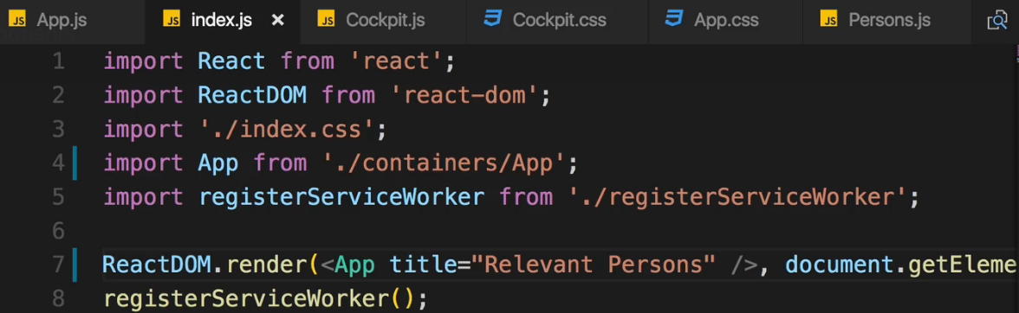  
=> In App.js  
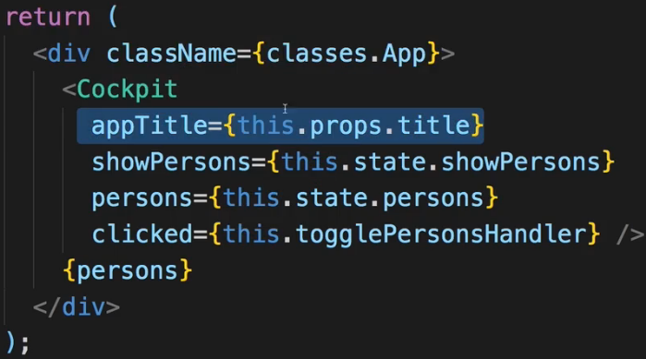  
=> In Cockpit.js  
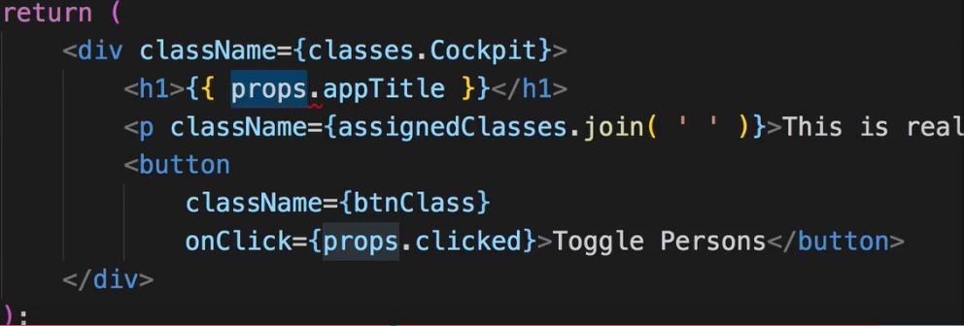  
**Understanding the Component Lifecycle**  
* In the end when React creates a component for us, that means instantiates and renders it for us, it runs through multiple Lifecycle phases. And we can define methods in a Stateful component which React will execute which allows us to run some code during some of these Lifecycle phases.  
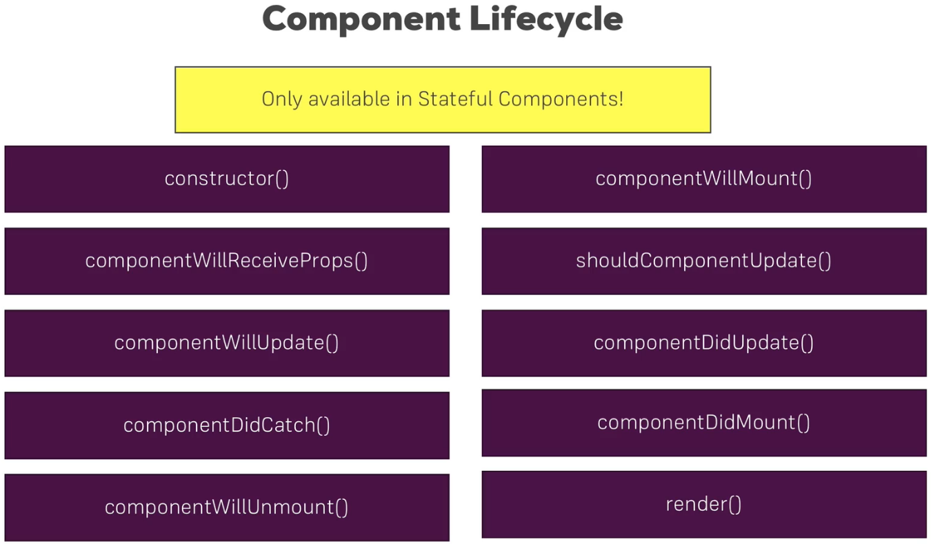  
**Component Lifecycle: Creation**  
=> constructor(), componentWillMount(), componentDidAmount(), render()  
**constructor()**  
=> Don’t for example reach out to a web server - so requests which come back and then edit the state if our application. That is the side-effect. You shouldn’t do that in the constructor because this may lead to a re-rendering of our application and hence to performance issues. It may also lead to your state becoming unpredictable.  
**componentWillMount()**\* You don’t really use it that much anymore.  
render()  
* Now executing the render method does not mean that it accesses the real DOM. We will come back to how exactly React renders the real DOM and updates the DOM later. For now you should know that executing the render method gives React the idea of what it should render. How it would look like if it then reaches out to the real DOM and manipulates it depends on what this real DOM looks like already. If no changes need to be made, it doesn’t go ahead and re-render it anyways. But the render method is an important step because it clearly defines how this component should look like from an HTML perspective.  
* Now there after React of course also knows which child components this component has. Because in the end once you call render and define your JSX code, it also knows which other components you included in there, like the persons component in our demo project. So it will then go ahead and render all these child components, basically executing this process for every child component.  
* And thereafter it will call componentDidMount()  
**componentDidMount()**  
* To basically tell you that this component was successfully mounted.   
* Now here you can cause side-effects. This is the point of time where you wanna reach out to the web for example to fetch some data.   
* What you shouldn’t do here though is update the state because that will trigger a re-render. So don’t call this.setState() in componentDidMount().  
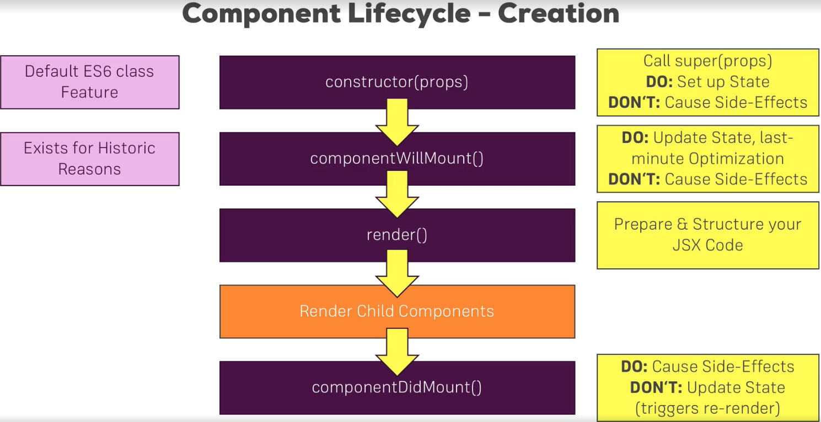  
**Converting Stateless to Stateful Components**  
* To really see how also child components get re-rendered I also want to turn some of our Stateless Components to Stateful Components so that we can implement these Lifecycle methods.  
* Let’s turn Persons.js and Person.js into Stateful Components.  
=> const persons >>> class Persons extends Component { render() { return }}  
=> use this.props instead of props  
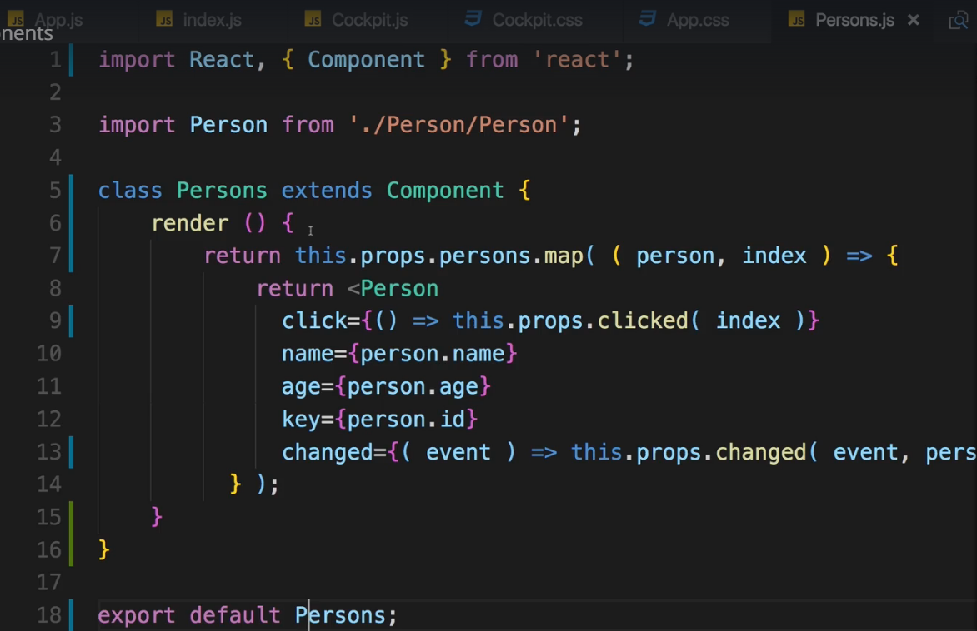  
=> Let’s do the same for the Person.js component.  
**Component Creation Lifecycle in Action**  
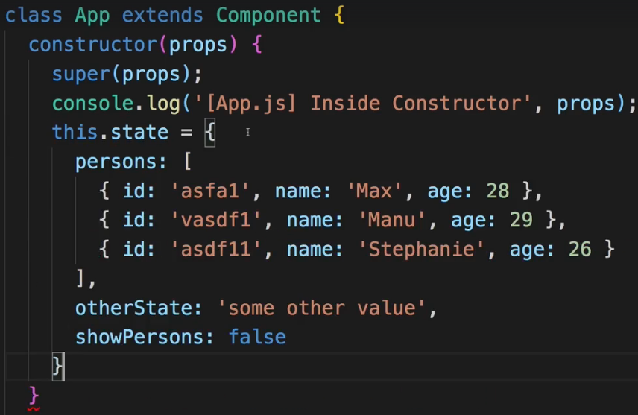  
=> **constructor(props) {super(props)}** is used automatically without even specifying it. It’s also easier to implement state initialization like we did before. In older versions of the project setup created for React we didn’t have access to this relatively new way of initializing properties in ES6 classes.  
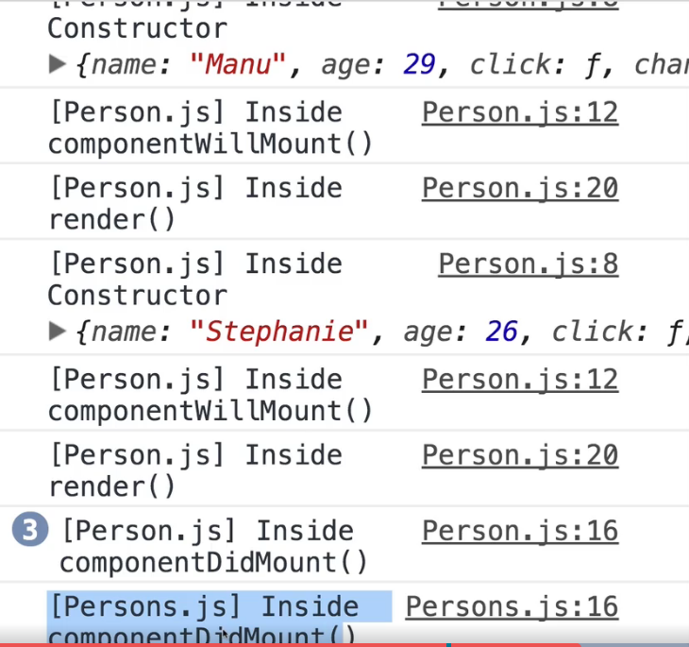  
**componentWillUnmount**  
<https://www.udemy.com/react-the-complete-guide-incl-redux/learn/v4/t/lecture/8140299?start=0>   
**Component Updating Lifecycle Hooks**  
* There we actually need to differentiate between **updates triggered by Parent - so changing props** and **internally triggered updates - so by changing state**.  
* The first method which then gets executed if we implement it is **componentWillReceiveProps(nextProps)**  
=> Here we can synchronize our local state of the component - if we have one - to the props.

=> So initialize the state with the props. So that we can then later change the state in that component but get the base state depending on the outer props.   
=> If you don’t need to synchronize this, you probably don’t need to implement this method.  
* Now after this method:  
**shouldComponentUpdate(nextProps, nextState)**  
=> So basically the props and state which triggered this update.  
=> This is a method which may actually cancel the updating process - you can decide.   
=> Because if you return `true` here, the updating continues. If you return `false`, the updating stops.  
=> In all the other methods you never return anything but here you can return true/false and it does have an impact.  
=> If you return `false`, you basically save performance because React doesn’t need to go through the whole component tree and call render and so on. But of course it may also show to your application showing an incorrect state or basically having an incorrect DOM representation if you use this in a wrong way.  
**componentWillUpdate(nextProps, nextState)**  
* If you do decide to continue, this one runs.  
=> Here you also get access to the upcoming props and the upcoming state.  
=> There again you may sync your state to props.  
=> It might be the better place to synchronize your state to props because unlike componentWillReceiveProps(), here you know that you’re going to continue with the updating. So you might not spend effort and resources for something which then doesn’t matter anyways.  
**render()**  
=> Once this has executed successfully you reach the render() method again. Hence rendering the JSX and telling React what will actually be the result of your updated component. Therafter React will go ahead and **update all child component props** and that of course may trigger updates for the child components.  
=> And then it will call componentDidUpdate()  
**componentDidUpdate()**  
=> There you may now cause side-effects just like in componentDidMount()  
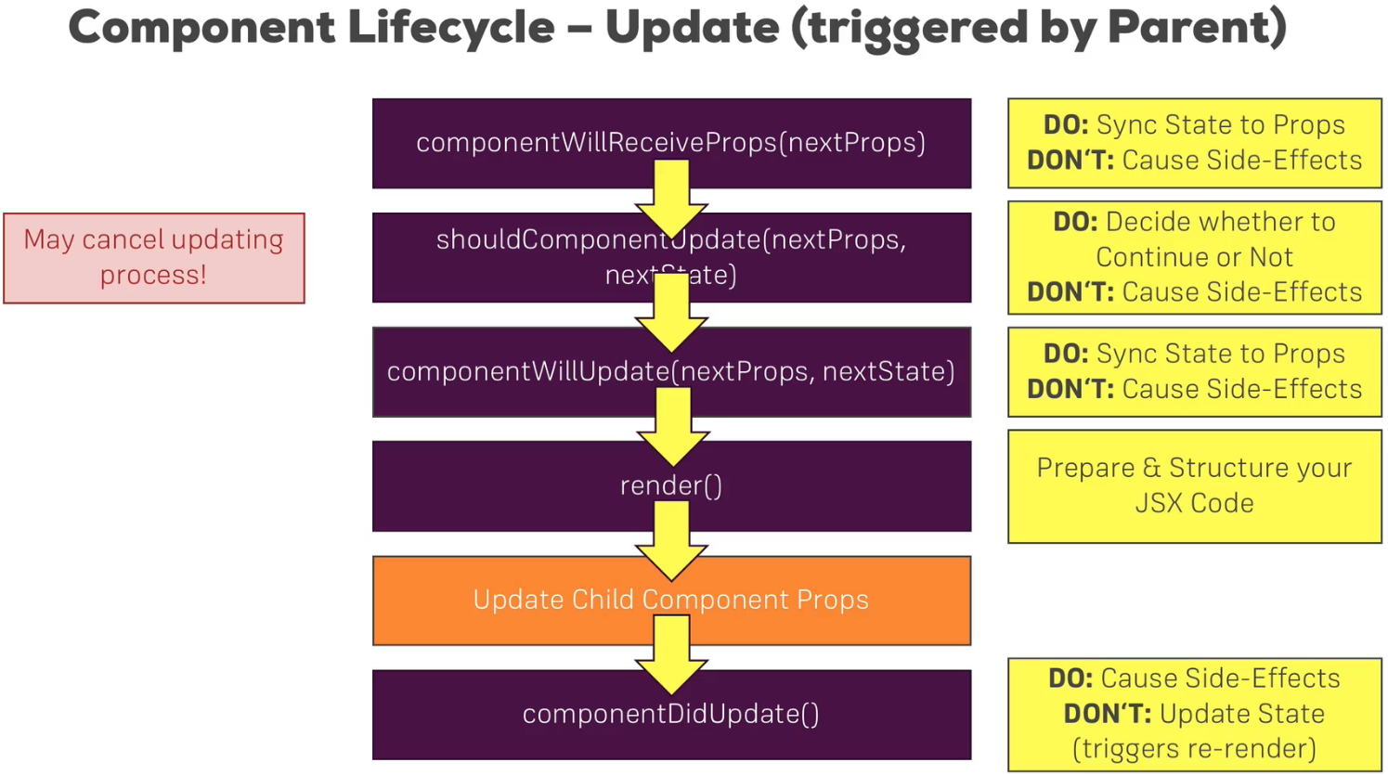  
**Component Updating Lifecycle in Action**\* We created the lifecycle methods like: method() {} instead of method = () => {} you could absolutely do that but since these methods are not called through DOM events, and therefore we will never have this `this` keyword issue, we may also use this syntax, which you might know from other programming languages too.  
* Now if we remove one of the persons, the render is called and then we see our update   
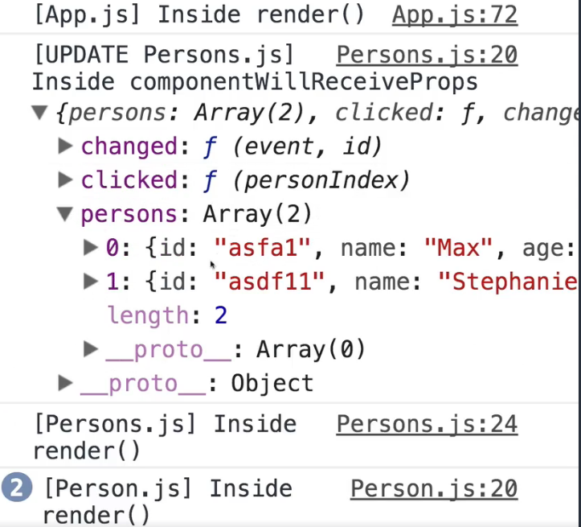  
=> We get the updates props where we have persons which is only 2 persons now.  
* Now the shouldComponentUpdate() is not just a convenients method but one where we can really save some performance if we cleverly use it.  
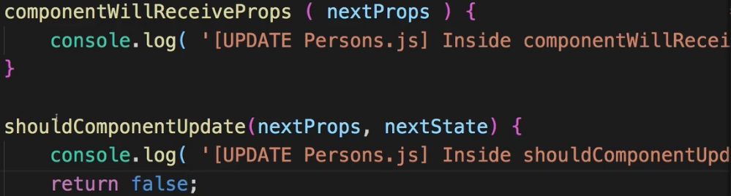  
=> Now if we click on a person to try to remove it, the componentWillReceiveProps runs but the element doesn’t get removed - it doesn’t update.  
=> Inside this method you can eve see the updated props - if we click on 2 persons, we see persons with only 1 person remaining in the props. It’s not reflected in the DOM though because we canceled the update process so we never reach the render() methods.  
* Why would we ever return false then?  
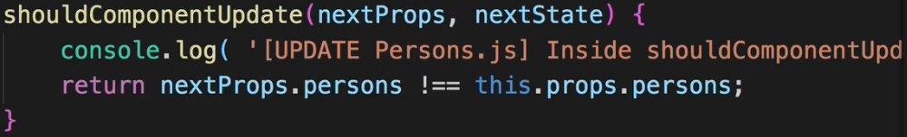  
=> You might have cases where you know that no update is required. And of course typically you don’t hard-code true/false here, instead you check that based on the upcoming props and/or state.  
=> So here for example we know that we only want to continue if nextProps.persons !== this.props.persons which are the old persons.  
=> By the way this check now is only true because we used an immutable approach of updating the persons array because this doesn’t deeply check the persons array, it only sees if it’s different objects but these are different objects because of the way we update persons here in our App.js file. There when we set persons, we set it to a new array. So it is a totally different object, that‘s important.  
=> shouldComponentUpdate doesn’t deeply check this - it only compares the root objects - the pointers to be precise, but these are different because we created a new array.  
=> But that out of the way what would now happen is if we somehow change some other property which might not be relevant for this component, this won’t trigger an update and we can save performance here.  
=> You don’t necessarily need to add it to every component because that would mean you should use Stateful components all over the place.  
=> But if you have a use case where you know - yeah, this component receives a lot of props but actually it should re-render if only one of these props changes, then you might turn your component into a Stateful one and implement shouldComponentUpdate(nextProps, nextState) to check whether the single prop which is important to you, changed or not and ignore all the other ones.  
* componentWillUpdate(nextProps, nextState) - now we know we want to update.  
componentDidUpdate()  
=> The nextProps, nextState are the current props and current state at this point.  
* So that’s the updating lifecycle - if the update is triggered from outside due to changing props, as it is the case for persons, the persons array changed.  
**Updating Lifecycle Hooks (Triggered by State Changes)**\* The props changes was **updating triggered from the outside**.  
* Now let’s take a look at updating for **internal changes** because of **setState()** basically.  
* There we don’t have the componentWillReceiveProps, we start with shouldComponentUpdate. That’s the only difference when it comes to the methods.  
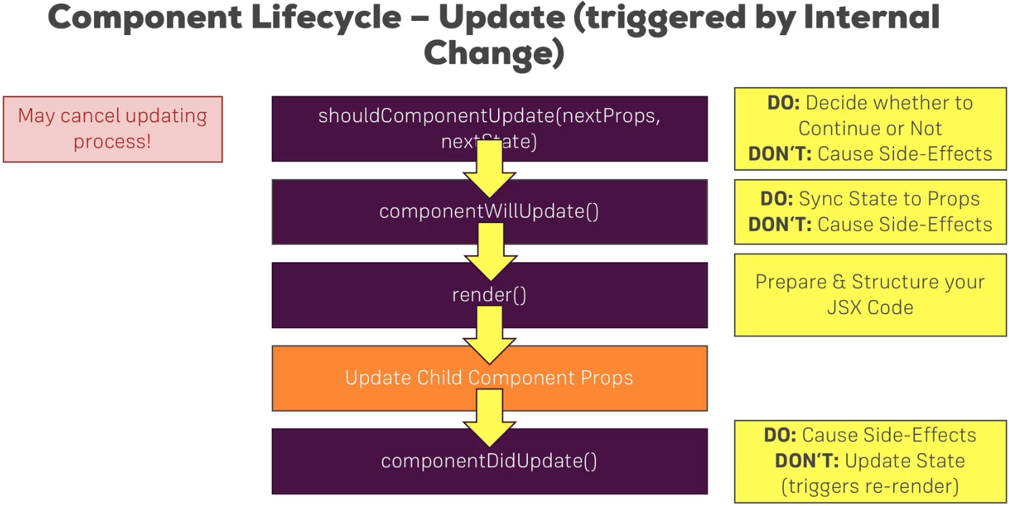  
=> When we click the button, the updating methods are called because clicking this button alone calls setState() and therefore triggered the updating of that component.  
=> Obviously before we change the props and therefore trigger the updating process in the child components because before we can change the child components, the state there has to update.  
=> This is important - the App.js updating runs first because it’s triggered upon a state change which obviously is the first thing that happens.  
* Now let’s go back to shouldComponentUpdate and how we may improve the performance of our application with it.  
**Performance Gains with PureComponents**  
* For the demo, let’s add a button which always shows the persons, that’s all it does. If they’re already visible, it doesn’t do anything… **or so you would think**.  
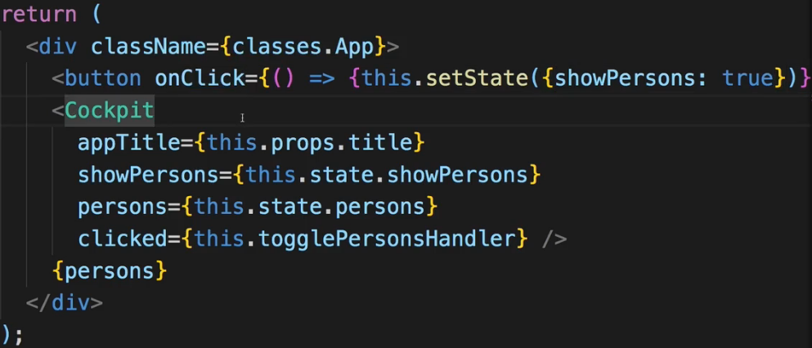  
* Let’s return true in the Persons.js - as if we didn’t implement it.  
* Now let’s show persons.  
* And now let’s click show persons again.

=> We go through all the Lifecycles again.  
=> React goes through the full component tree and all the render methods even though nothing changed.  
=> Now don’t mistake this for React re-rendering the actual DOM - the browser DOM, it didn’t do that. You can confirm this by going in Chrome Dev Tools > Audits > Elements > … options > More Tools > Rendering - you can turn on the Paint Flashing to see areas that need to be repainted - if you click the show persons button, you see only the button needs to be repainted. For toggle persons you see a lot needs to be repainted. So it doesn’t touch the real DOM. It only touched the button.  
=> Going through all the render methods even though nothing changed really can be a performance issue.  
=> That is why prior to that we had this check in Persons.js in shouldComponentUpdate.  
* Let’s now bring it back, we can also add more checks - for all the relevant props.  
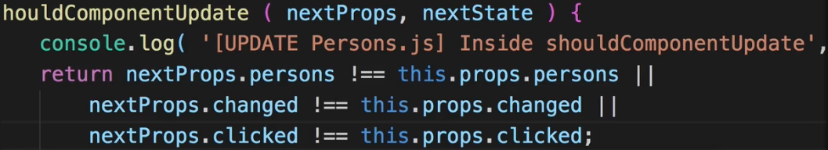  
* When we click show persons now (when it’s already showing), we are inside shouldComponentUpdate from App.js, componentWillUpdate from App.js, render from App.js, but then for Persons.js we are at componentWillReceiveProps, shouldComponentUpdate and we’re done, we don’t continue. We don’t call render for persons and the individual person components because we detected that the props didn’t actually change.  
* We can add some checks in App.js too.  
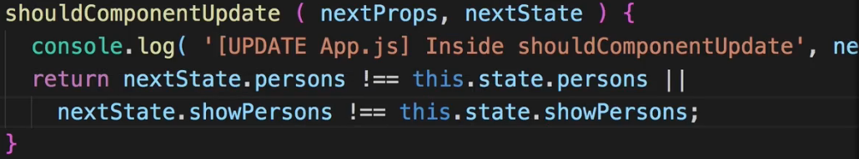  
* Now if we click it the second time, we only reach shouldComponentUpdate and that’s it.  
* If we remove a person, then it goes correctly go through all these steps.  
=> This way we make sure that we only run through the updating process if we need to do that and we skip unnecessary work and of course therefore performance hits if we actually don’t need to do updates because we know nothing changed, no need to do all of that.  
=> Now for this check where we see if the state properties or the props properties - if any of these change, this is a check we don’t have to write on our own, if that is what we wanna do, make this **shallow comparison** - I’m saying shallow because it doesn’t deeply check these objects, it only detects differences because we update them in an immutable fashion, which is important. So if we want to make this shallow chance, we actually don’t have to implement shouldComponentUpdate, instead we can inherit from a different type of component  
**PureComponent**  
  
=> This is a different object exposed by the React library and it is exactly the same as the normal Component but it has this type of shouldComponentUpdate check already built-in.  
=> It’ll basically go through all the properties in the props and compare them to their old versions and only continue updating if it detects differences. And it does the same for state.  
=> **Should you then always use PureComponents for your entire application?** And how does this make sense if I tell you to use Functional Components as often as possible where you can’t use this because you don’t extend anything?  
=> You should only use it if you know that updates might not be required. On the other hand you have components which might only depend on 1 or 2 props and you know whenever an update is triggered for this component, I want to update it - because maybe I got a couple of PureComponents at top positions in this component tree which prevent the updating of any child component anyways.  
* So don’t make everything a PureComponent because you also can get a performance hit there. In the end, this implemented shouldComponentUpdate for you and it compares all the old props and states to the new props and states. This of course also takes a bit of performance and if you implement it somewhere where it will always succeed, because you already did this check in a higher point of this component tree, then you’re really hurting your application.  
=> Some strategically placed PureComponents make a lot of sense though.  
=> Now to find out where to place them, we need to get a better understanding of how React walks through our component tree and how it actually decides to really update the real DOM.  
**How React Updates the App & Component Tree**  
* The Updating happens from top to bottom and only when STATE or PROPS change.  
=> So if the state in the Shop component changes, List and Cart will probably receive new props and also update.  
=> And this also gives us an idea about what might be pure components and where this doesn’t make too much sense.  
=> If we have List and Cart depend on PROPS which are distributed by Shop, then maybe it makes sense to implement **shouldComponentUpdate()** in the Shop case and STOP updating if the state didn’t actually change - if we maybe called setState() but the properties in the state are still the same as before, and then List and Cart won’t be reached anyways. So there’s no need in turning List and Cart into PureComponents because we have a good check one level above them.  
=> So having some containers where you have these checks might make a lot of sense.  
=> And still you might even find cases where your containers don’t need that check because you know you only call setState() or you only receive new PROPS if they really changed so you can also leave out shouldComponentUpdate() or PureComponents. But oftentimes it might make sense.  
* So this is how the rendering and updating works, how this tree of components is updated and handeled by React and how you may optimize it.  
* Let’s now understand how React optimizes this updating process for us out of the box by not hitting the real DOM all the time. Because there is a big difference between the render() method being called and the real DOM being changed.  
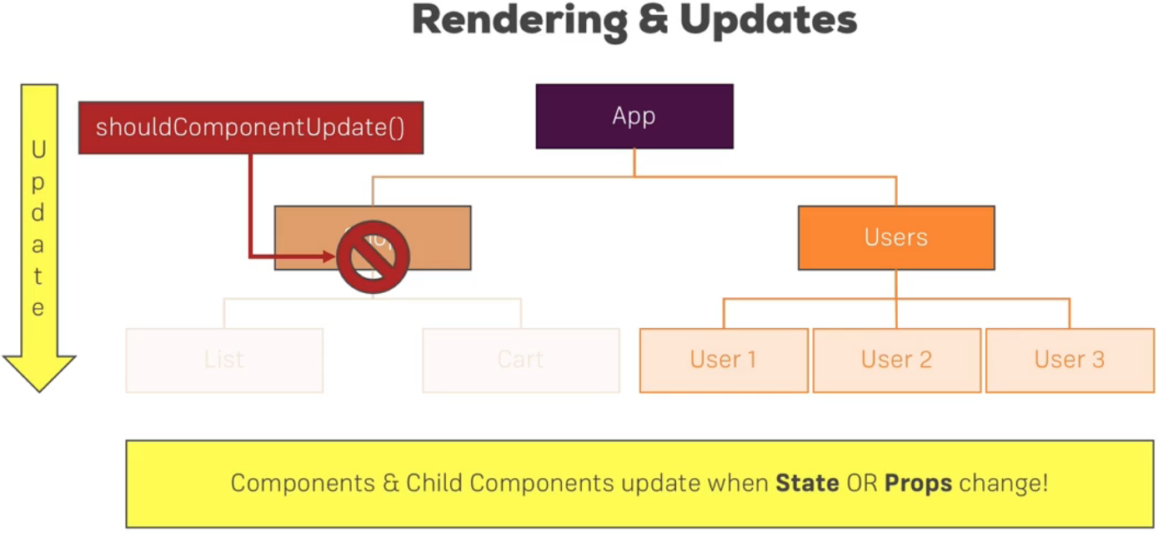  
**Understanding React’s DOM Updating Strategy**  
* The render() method being called does not also immediatelly render this to the real DOM, he name can be misleading.  
=> This does not mean that it renders it to the real DOM, render is more a suggestion of what the HTML should look like in the end. But render can very well be called and lead to the same result as is already displayed. And that is part of the reason why we use shouldComponentUpdate() to prevent unnecessary render() calls. But even if we don’t catch an unnecessary render() call - maybe a PROP did change and still we would render() the same result, for whatever reason. Even then this does not mean that it immediatelly hits the real DOM and starts re-rendering it.   
=> Instead, it first of all does something else.   
=> It compares **VIRTUAL DOMs**  
=> IT has an **Old Virtual DOM** and the **Re-rendered Virtual DOM** (or = **Future Virtual DOM**)  
* React takes this Virtual DOM approach because it’s faster than the real DOM.  
* A Virtual DOM simply is a DOM representation in JavaScript.  
* You can of course represent all HTML and therefore DOM elements and objects in pure JavaScript, so without rendering anything to the browser.  
* And this is what happens here:  
=> React basically keeps 2 copies of the DOM - the Old and the Re-rendered.   
* The Re-rendered is the one which gets created when the render() method is called, now as I mentioned though - re-rendering or calling render() doesn’t immediatelly update the real DOM.  
=> Instead React makes a comparison. It compares the old virtual DOM to the new one and it checks if there are any differences.  
=> If it can detect differences, it reaches out to the real DOM and updates it. And even then it doesn’t re-render the real DOM entirely - it only changes it in the places where differences were detected.  
=> For example if a button text changed, it’ll only update that text and not re-render the whole button.  
=> If no differences were found, then it doesn’t touch the real DOM. Render() did execute, the comparison was made, and that is why shouldComponentUpdate() might make sense to prevent this if it’s not needed because this of course already also costs some resources but nonetheless the real DOM is never touched, you can rely on that, the real DOM will only be touched if there are real differences. This is important because accessing the real DOM is really slow. This is something you wanna do as little as possible.  
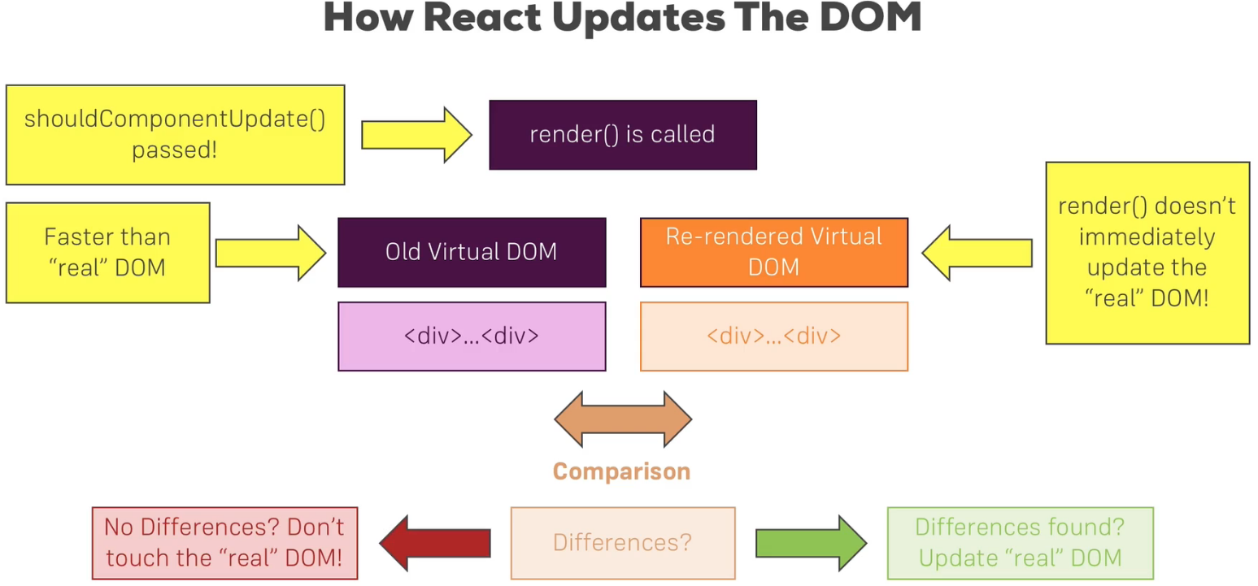  
* You can notice that in our app - when we show the persons, they flash in the dom, but nothing else flashes. Or when only the text flashes because only the text is changed, not the whole element.  
**Returning Adjacent Elements (React 16+)**\* Our components typically have a wrapping element, you must not have multiple elements sitting next to each other on the root level inside the return statement of your return method. This restriction is, however, loosened with React 16. For example in Persons.js we have no issue returning the Person array.  
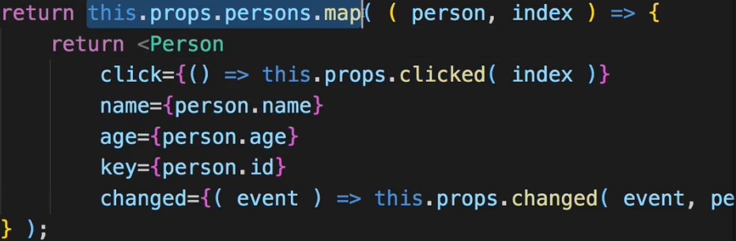  
=> We’re mapping this JavaScript array into an array of JSX elements.  
=> You may return an array of elements. This is something which is okay. - NOT elements sitting next to each other, but if it’s an array of JSX elements, it works.  
* You could do the same in Person.js. You could return an array of these 3 elements, each array item then also needs to have a key though.  
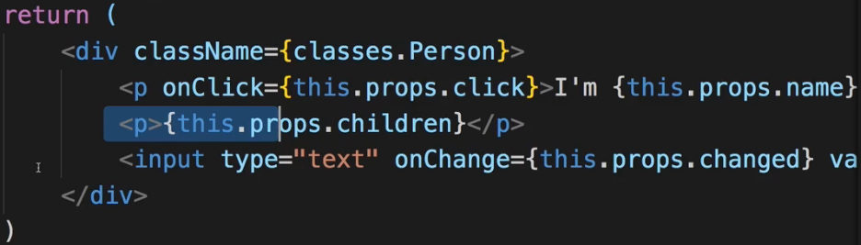  
=> So no matter if you automatically generate your array with the .map() method or if you do it manually. Having a valid array though you need to key it. In this case the wrapping div contains styles so it’s not ideal here.  
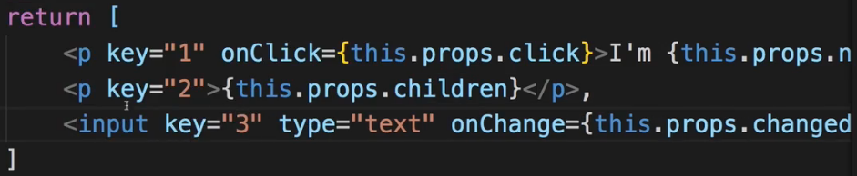  
* You will most of the time have code with the wrapping div and not return arrays. The exception is components which handle the rendering of lists  
* Now there is another exception - in our Cockpit file there we also have the wrapping DIV - to apply the Cockpit class. We don’t need the .Cockpit class besides the button and so on which we want to scope for this component. We can use .Button instead of .Cockpit and have it scoped to the file.  
* Now we need to adjust these classes and use an array with .join.  
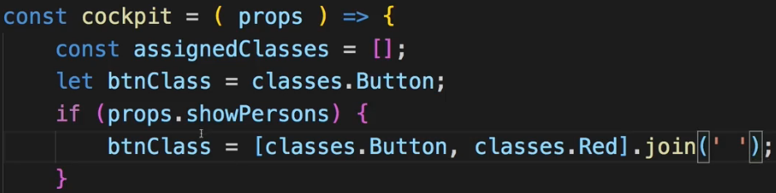  
=> Now the wrapping array is redundant so we can remove it.  
=> We could return an array of elements.  
=> But there also is another alternative - we can create a **Higher Order Component** for that.  
=> I’ll create a folder `hoc` for Higher Order Components in the `src` folder.  
=> Higher Order Components are absolutely normal React components, they have 1 specialty though - they are not representational but they wrap other components to add a certain functionality.  
=> For example we can create an `Aux.js` component (for `Auxiliary`) and this component will have 1 single task - it will be a function which gets props which returns some JSX, in there all I want to do is output **props.children**.  
=> This component might look useless because all it does is returning what’s passed between the opening and closing tag.  
=> This, however, is huge because we can now use this `Aux` component in the `Cockpit` component.

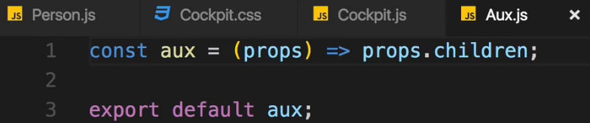  
* Now in Cockpit.js.  
  
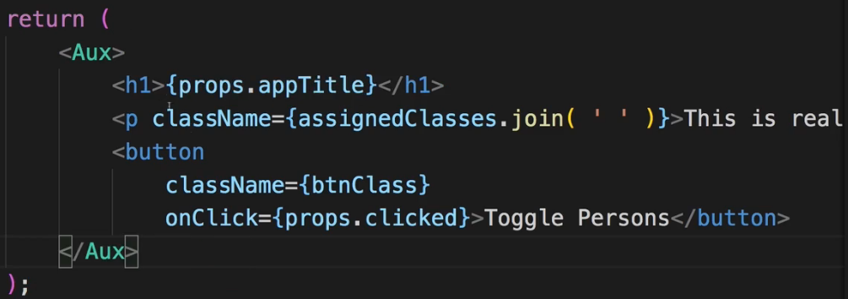  
=> Now we no longer get an error here because we have a wrapping component, but we don’t actually create a wrapping HTML element because Aux is empty. We may just return props.children. That is the key takeaway. We don’t have to wrap this.  
=> And even if props.children are then adjacent HTML elements, as it is the case here, it will still work in React 16.  
=> That’s pretty cool because sometimes you don’t want to introduce a separate HTML element, like a wrapping DIV, if you don’t need it for styling reasons. It can even destroy your styling if you’re using flexbox or something like that.   
* All we do in Aux is distribute props.children so we don’t even need to import anything.  
=> So now we save this extra redundant HTML element here in Cockpit - this DIV which we don’t really need.  
**React 16.2 Feature: Fragments**<https://www.udemy.com/react-the-complete-guide-incl-redux/learn/v4/t/lecture/8672134?start=0> If your project uses **React 16.2**, you can now use a built-in "Aux" component - a so called **fragment**.It's actually not called Aux  but you simply use <>  - an empty JSX tag.  
So the following code

1. <Aux>
2. <h1>First Element</h1>
3. <h1>Second Element</h1>
4. </Aux>

becomes

1. <>
2. <h1>First Element</h1>
3. <h1>Second Element</h1>
4. </>

Behind the scenes, it does the same our Aux  component did.  
**Understanding Higher Order Components (HOCs)**  
* You can create them and you’ll often use some when using third-party packages - they add a certain logic to a component - some logic you might need in multiple components and which you don’t want to write into each of them.  
=> For example: share a locked-in user.  
* For the Person.js component - we wrap it with a DIV with a classes.Person as a class name.  
* In App.js we do the same - a DIV with a classes.App.  
* To use Higher Order Components to do this there are actually 2 approaches we can take.  
=> 1. => let’s create WithClass.js file, all we do is return some JSX where we have this wrapping DIV and there we set className to received props.classes and then output props.children inbetween.  
* If you return JSX, you need to import React.  
* props.children is what’s inside the <> </>  
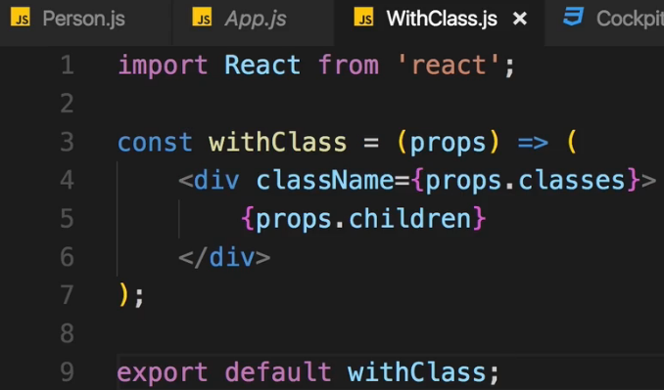  
=> Now we can use the WithClass wrapper.  
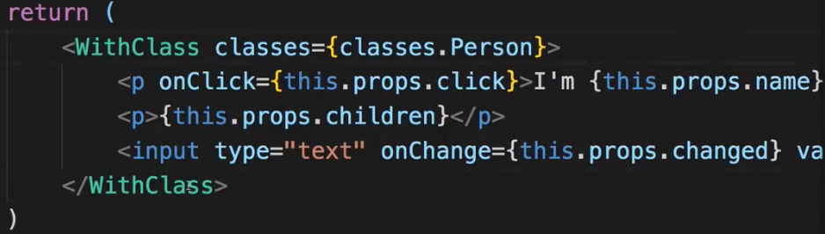  
=> So we basically replaced the DIV with WithClass. It’s a nice example of a HOC component even though it doesn’t do anything then wrap the content in a DIV.  
Windows Users Must Read - File Downloads  
<https://www.udemy.com/react-the-complete-guide-incl-redux/learn/v4/t/lecture/8304962?start=0>   
**A Different Approach to HOCs**  
* We can write it differently - let’s name it withClass.js with lower case letter. That’s just a convention for this kind of HOC. It is used a bit differently.  
=> This time this is not a function which takes the props but a function which takes some configuration, like the className.  
=> And then this will return a function, which receives the props and which will in the end then render something.  
=> And we will not only get the className - we expect another argument: the wrapped component.  
=> And the WrappedComponent will actually be used inside as a self-closing tag.  
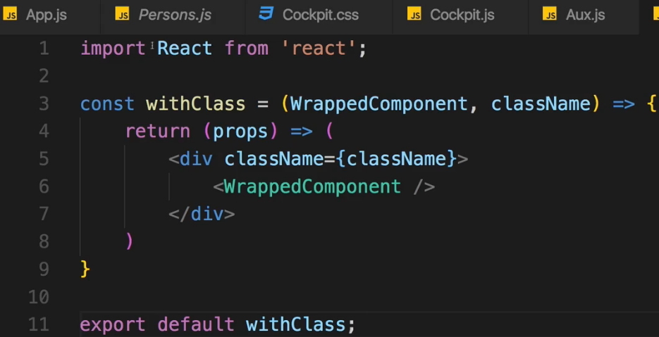  
=> Now keep in mind this withClass function is not a Functional Component, it’s a normal JavaScript function which expects 2 arguments which then returns a function which qualifies as a Functional Component.  
=> We have a valid JSX code here where we are wrapping our component but now we can use this a bit differently.  
=> We can go to App.js file   
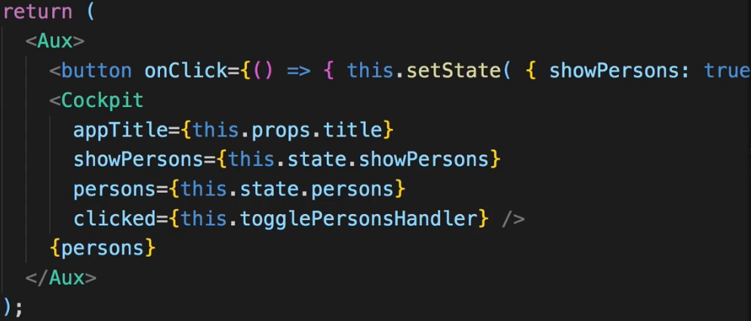  
  
* Now it doesn’t work - all the dynamic elements, all the props on the persons are missing.  
=> Now generally our HOC here is working and this is a pattern you’ll often see.  
=> If you plan on changing your component like this wrapping it or doing some other transformation with it.  
=> One thing you should never do here though is manipulating the WrappedComponent, just use it as we do here. Don’t start adding or changing its state or properties.  
=> And as a side-note you’re not limitted to returning a Functional Component here, you can also return a Stateful component.  
=> Now let’s find out what’s wrong with these props.  
**Passing Unknown Props**  
=> To make the props work there’s 1 single simple thing we should do.  
=> Just **pass on the existing props**.  
=> You take advantage of an ES6 operator - the **spread** **operator**.  
=> Keep in might that props are just an object of key-value pairs. Now you can output some dynamic content on this WrappedComponent with {…props} to simply split it up into these key-value pairs and pass them to WrappedComponent. It simply means pass on the props as you get them, don’t do anything else with them, just pass them on, split them up into key-value pairs, so that you can validly assign them to this WrappedComponent.  
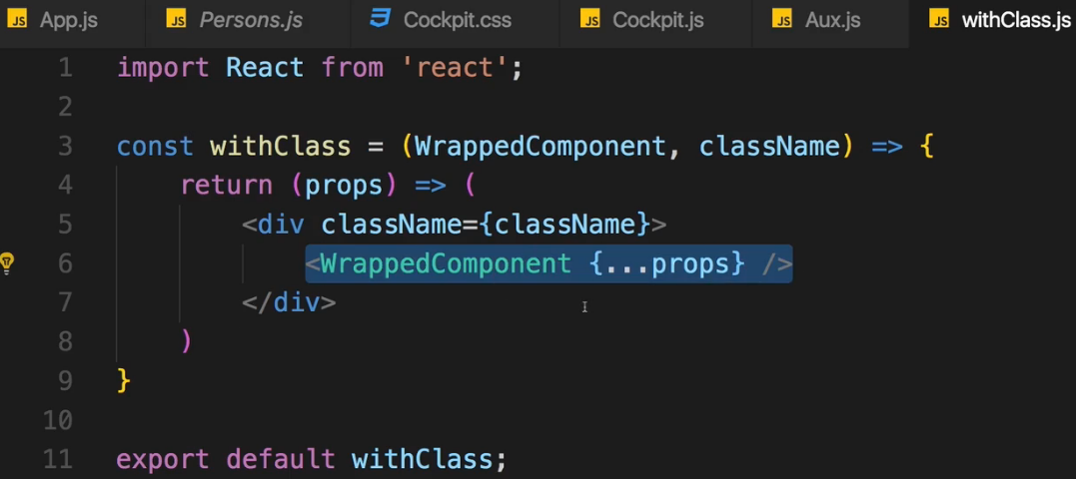  
=> So now we have a truly reusable HOC.  
* One other thing - this HOC doesn’t have to return a Functional Component - it depends on what you need to do in your HOC - if you need access to Lifecycle hooks, for example if you plan on reaching out to the web and fetch the currently authenticated user and kind of do something with that - if that’s your plan, you’ll need a Stateful Component.  
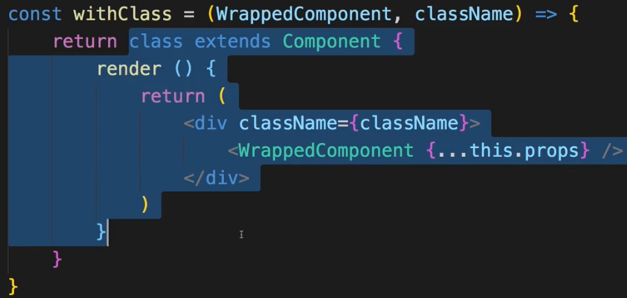  
=> A normal Stateful Component, the only difference is that after the `class` keyword there is no name - because it’s like an anonymous class, we’re returning it, we’re having a class factory here.  
* There are also many third-party packages which use HOCs.  
**Using setState() correctly**  
* We already learned to use it in an immutable way.  
=> So if we assign a persons array, we create a copy of that array so that we don’t mutate the original one and then we mutate this copy and assign the changed copy as a new state.  
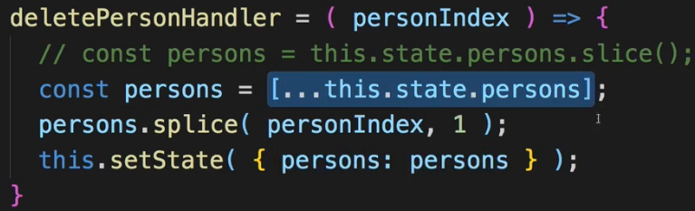  
* Now sometimes you have a state update which depends on the old state and is a bit more trivial.  
=> Let’s say we wanna have a counter on how often we click the toggle button.  
=> In our state which we now initialize in the constructor since the Lifecycle lectures (you can use it without it though), there we might have a toggleClicked counter which is 0 initially.  
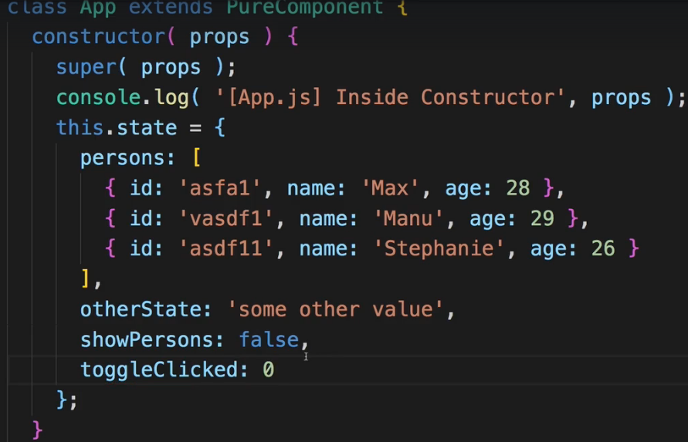  
=> Now in our togglePersonsHandler here we call setState and there we would now also of course update toggleClicked, and the value of course depends on the old value of toggleClicked because it should be the old value +1.  
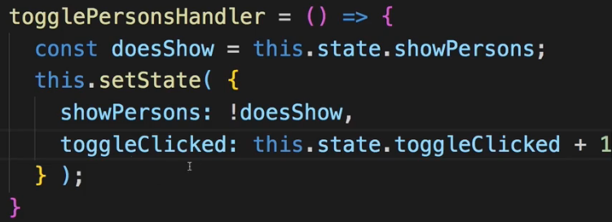  
=> Now it’s working correctly and **still it’s the incorrect way of doing that**.  
=> Because setState actually is a method executed asynchronously by React. Which means you can’t rely on this.state being called inside setState to really reflect the latest version of the state.  
=> If you call setState somewhere else in the application, basically around the same time, the other setState call might finish BEFORE this one. So this.state in here might not be correct.  
=> So there is a better syntax for calling this.stateState if you plan on using this.state inside of it. And this is the functional form, the function syntax of it.  
=> setState then takes a function and there you get 2 arguments - the prevState which you can safely access then because this definitely is the last state it had it at this point of time and any props you might have. And then in the function body you have to return an object, which is your updated state.  
=> This is now safe to be accessed because prevState can’t be mutated from anywhere else in the app.

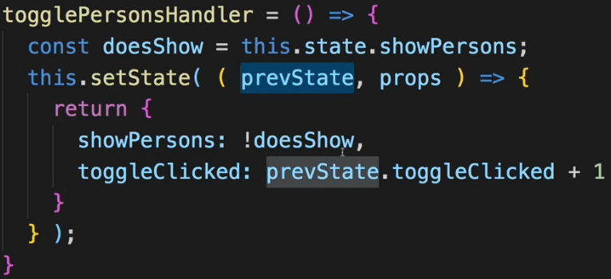  
=> This is how to call setState() correctly if your new state depends on the old state and there is a danger of editting this old state at the same point of time anywhere else in the application. Because setState() actually runs asynchronously.  
=> This is the best practice.  
**Validating Props**  
* We also have a better way of handling props.  
* At least in some use cases this might be better, mostly if you write Components which might be used by other developers during their development process.  
=> You can restrict the types and values you receive for your props. Like for Person.js. There we receive 4 important props. We can enforce certain values to really ensure that the props are always the types we want. Age could be a string or a number but if we do some calculations with the age, we need a number.  
=> We can make sure that a warning or an error is thrown during development if a developer uses our component incorrectly.  
=> We want to check the types of the incoming properties to make sure that they are getting used correctly.  
**npm install --save prop-types**  
(--save is to save an entry in the package.json file)  
* This is by the React team, just outsourced into its own package.  
  
* You simply use it by going bellow your class definition, then taking your class and there you add .propTypes property. You’re basically editting this class after it was defined.  
=> .propTypes is a JavaScript object and there you can now have key-value pairs where your keys or properties are the names of the props so click, name, age, … and the values are conditions, the rules.  
* There are even more advanced types, you can even define the exact shape of object you’re receiving so which properties it should have and which types the properties of that object should have.  
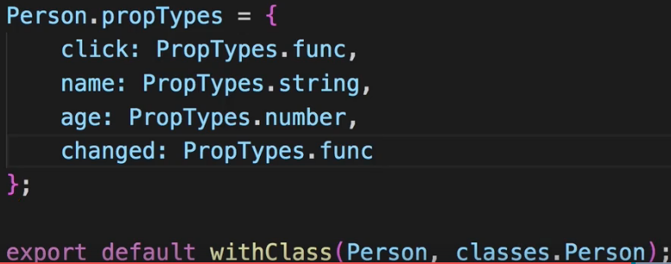  
* You don’t have to use PropTypes in every component you define, again one reason that speaks against it is that it doesn’t work in Functional Components which you should use as often as possible. But in some root level components you might want to control which property enters it and which property you pass on. It’s especially important if you work with other people.  
**Available PropTypes**  
<https://www.udemy.com/react-the-complete-guide-incl-redux/learn/v4/t/lecture/8302820?start=0>   
**Using References (“ref”)**  
* There’s one last feature which you won’t use too often but which can be extremely valuable for some tiny convenience things you wanna do in your components. Mostly when focusing text inputs and stuff like that.  
=> Let’s say we wanna focus the text input of the first person here whenever it is rendered to the screen. Now focusing that input is actually not that straight forward here because we would like to call the focus method we can get on this element at a certain point of time. So for example in componentDidMount().  
=> For that we need access to the input element so that we can call the focus method from this method. And there might be some workaround which you may find where you’re setting some state and then rendering this input conditionally in the focused state or the unfocused state and actually oftentimes you should try to use these workarounds but especially for focusing there’s a quick and easy way which is perfectly fine to use.  
=> A reference.  
=> You can add a special attribute to input `ref`, just like `key` it’s a special property/attribute known by React.  
=> `ref` takes dynamic input which should be a function.  
=> And in this function you set up a reference to this element.  
=> So as `input` you get access to this element, you can name this whatever you want and in there you can now define a property of this class.   
=> And this already is important - **references are only available in Stateful Components**.  
=> There you can then add a new property to the class by adding this.something and assign some value to that property. The value should be the element you got the access to.  
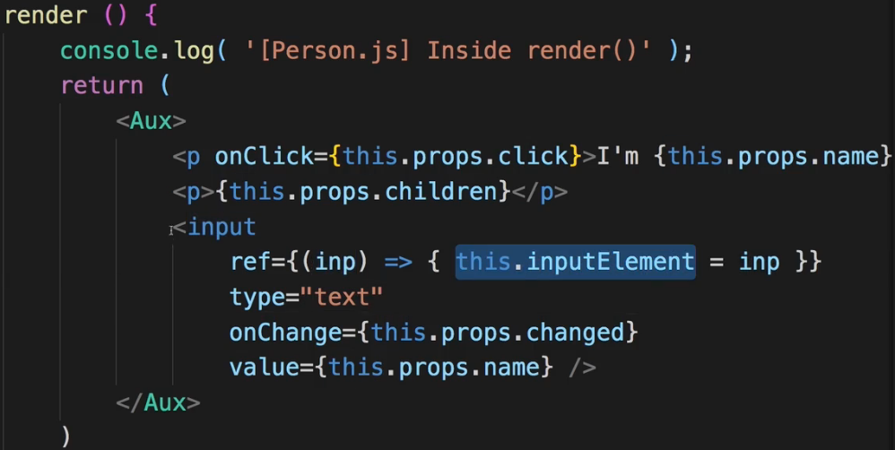  
=> This will create a new property for your entire class which you can therefore use from anywhere in the class. And it will be created at the point of time render() runs. So if you later try to access it from within componentDidMount(), that will work because it’s executed after render().  
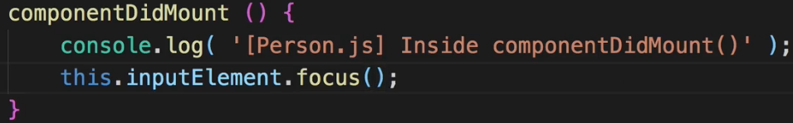  
* So now we have a property on the class which gives us access to this input element.  
=> Now you see that the last element is focused - the last one because focus is called for everyone and therefore since only 1 element can be focused at a time, it simply sticks to the last one which was rendered, the last one which called focus().  
=> Now if you want to make sure that the first element gets focused, you would need to pass the position, which you have in your Persons.js file where you loop using .map() with index, you’d have to pass this as a prop.  
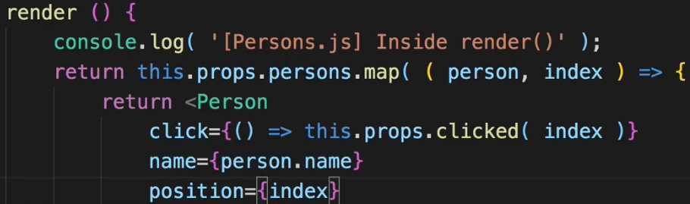  
=> And if position is 0, then you’d call this.

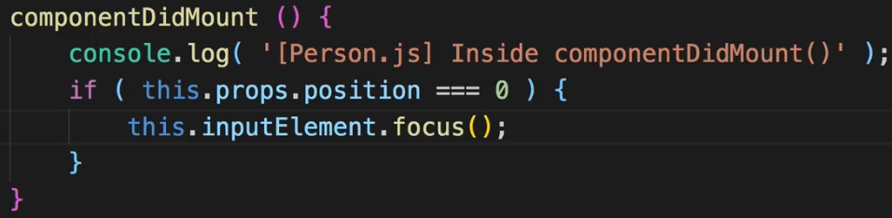  
* You can also use refs on your own components, not just HTML elements.  
* And you should use them with care - don’t try to get lazy and certainly don’t do things like this.inputElement.style.color = something - do this with the previous tools you learned for dynamically adjusting styles or for doing anything dynamic. This should not be your shortcut for being lazy, it is for a few selected things, mostly really about controlling focus, or media playback and not for styling or displaying. That’s the React way.  
**More on the Ref API (React 16.3)**  
* Now for working with REST, React now has an easier way.  
* Make sure you’re using React 16.3+.  
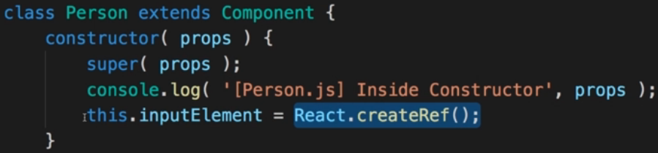  
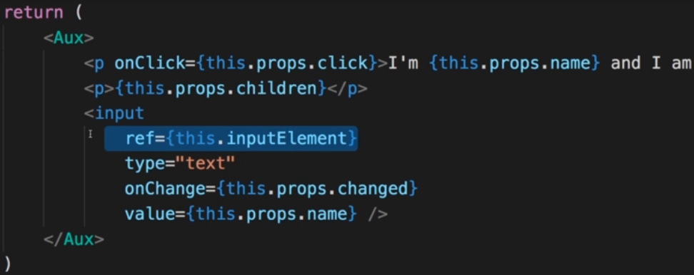  
* Instead of accessing the element directly, we call the .current property on it because the this.inputElement turns out to be a wrapper component/element provided by React and .current gives us access to the underlying DOM element.  
* React 16.3+ also introduces support for `**forwarded references**` - this means that we actually get a reference from outside of a component through that component.  
=> This is **especially helpful when working with wrapper classes like the WithClass.js component so with HOCs I wanted to say**.  
=> So Person for example is wrapped by the withClass HOC and we can actually get access to the Person component from the parent component so from Persons.js even though Person is wrapped.  
=> In the Persons.js let’s say we wanted to get access to the last Person we’re creating.  
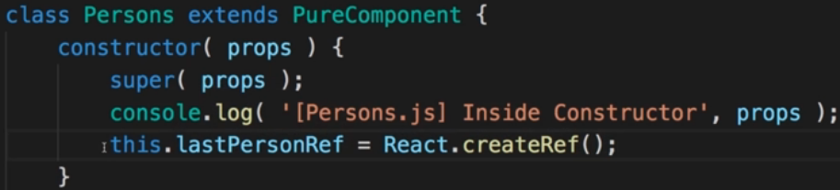  
=> And now I want to assign the last Person we’re creating down here to this reference. The last one simply because we’re looping through all the persons and if we assign a reference to each of them, only the last one persist because we’re constantly overwriting the same reference. We could’ve of course stored it in an array but for simplicity let’s do it this way.  
  
  
  
  
  
  
=> In Persons.js.  
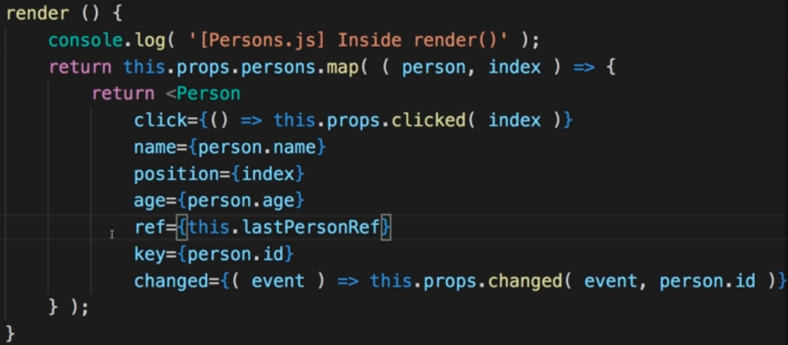  
=> Now in Person.js.  
=> We add a new method which we then could call from outside through the reference, and here we actually use our reference in that component to focus it.  
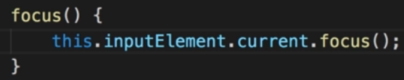  
=> In Persons.js.  
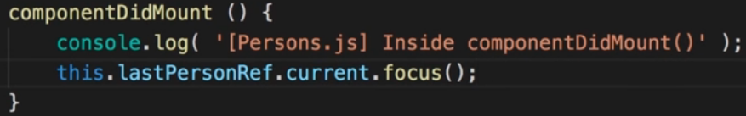  
=> If we do this, we get an error. Now the problem here is that we got the withClass HOC inbetween, if I temporarily remove that in Person.js, it’ll actually work fine because we’re now calling the focus method in the Person component for the last person in our array of persons, we do that with a reference to our own component, this works fine. However, we do have that HOC and this does actually not forward the outer reference, this is just how React works - the ref property is a special property and it’s not forwarded even though in withClass we do distribute all our props on the WrappedComponent.  
=> Now we can fix this issue in our HOC - for the WrappedComponent we have to forward the reference, so we have to set the `ref` attribute here because this WrappedComponent will be our Person component in the end. For this, however, we need to get that reference from outside, we wanna forward it - so we wanna get that reference we’re assigning in the Persons.js component in our case.  
=> To do this, we need to get access to this forwarded reference and we can simply assume that on our props we have let’s say a forwardedRef - this this name is totally up to you though.  
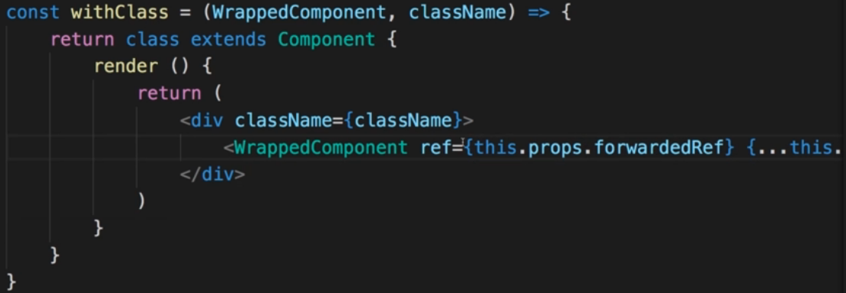  
=> So now we’re accessing this, however we won’t have this property on our props - to ensure that we got it, we simply go to our Persons.js component where we are passing ref and instead of passing ref we now pass `**forwardedRef**`.  
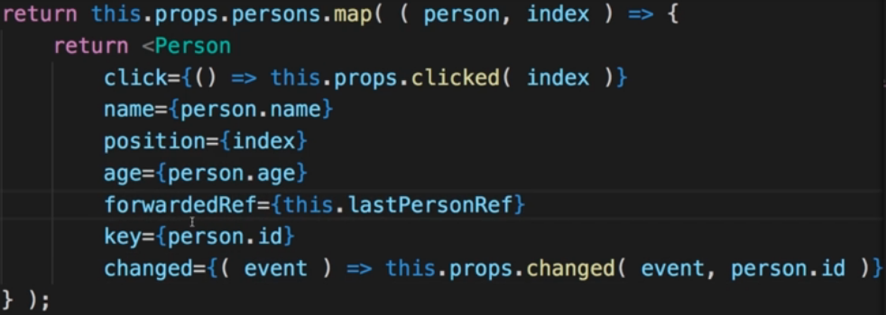  
* Now you might think that this is it so if we save it, it does indeed work. It is, however, inconvenient that you have to manually set forwardedRef here in the Person component in Persons.js. It’d be nice if we could still use ref.   
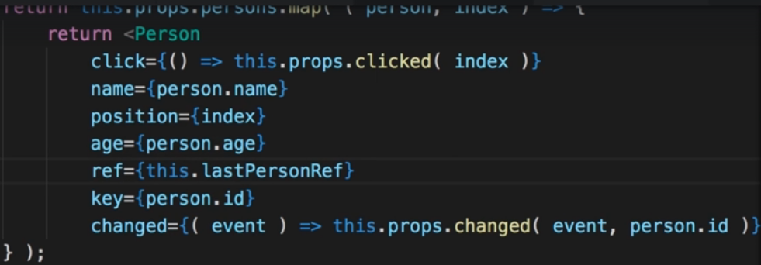  
=> And then we go to our WithClass.js HOC and in there we can use the new `**forward ref API**` that React 16.3 introduced.  
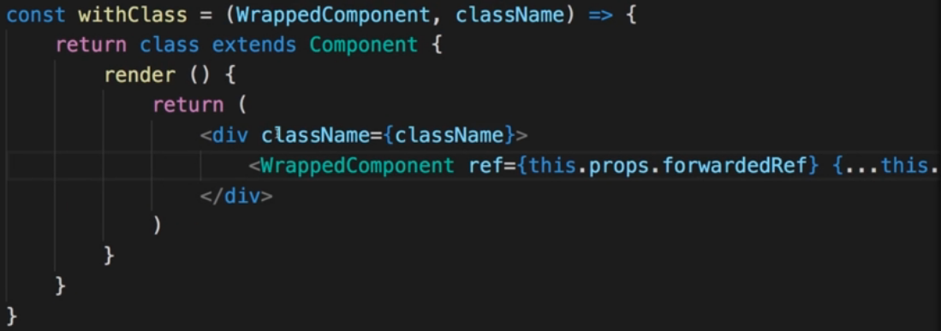  
=> Instead of returning the class here, we can first of all store it in a constant, and we wanna return that, however, what will actually return here is we’ll return a call to React - React.forwardRef() and this in turn receives an argument which is a function that gets the props and the reference argument, and we’ll then here return WithClass, distribute our props into it and also set that forwardedRef to the ref we’re receiving.  
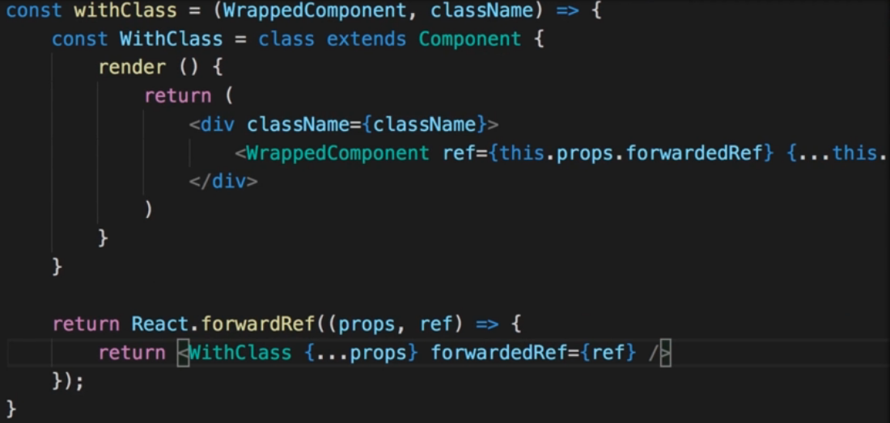  
=> Now this entire logic is contained in our HOC.  
=> Now it still works as before - and it’s not an issue for components when we used that HOC without setting a ref btw, but we don’t have to set the forwardedRef property in our other components - it’s all included in that WithClass.js HOC which of course is way more convenient then having to manually adjust all the names.  
=> So this is how we can work with refs, how we can simply use that easier syntax with just React.createRef() and how we can also forward references, this is something you might not need that often but if you need it, it’s really useful.  
**The Context API (React 16.3)**=> A great tool for passing global state around in your app.  
=> What does it mean? Let’s say in our Cockpit.js file we have a new button bellow the button we already have. I’ll add text “log in”. Now this button once clicked should actually set some global log-in state to true and change something on different components.  
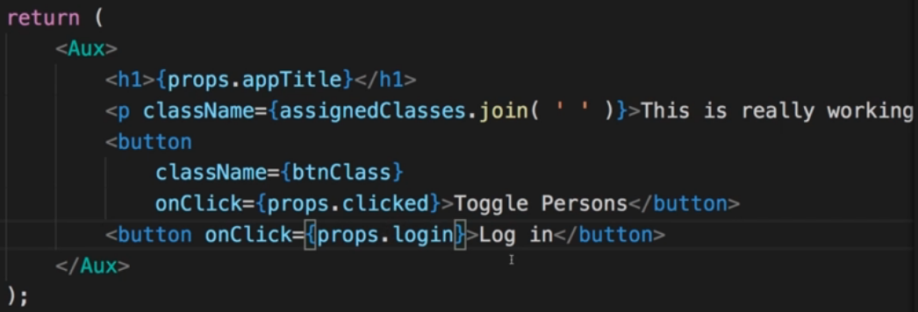  
=> In App.js file where we use the Cockpit.  
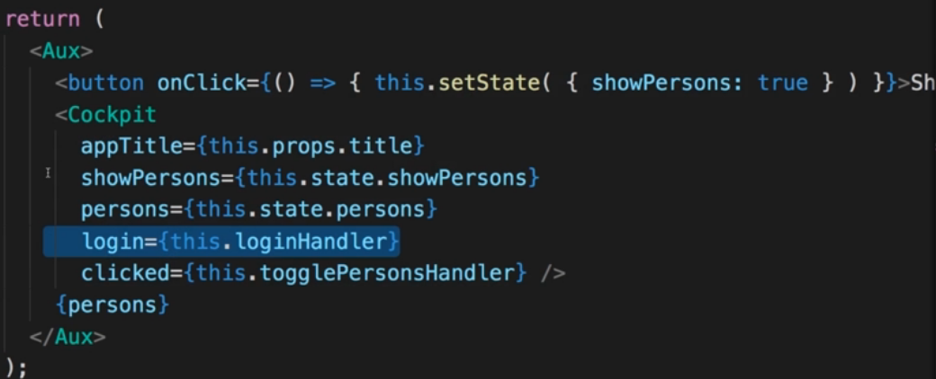  
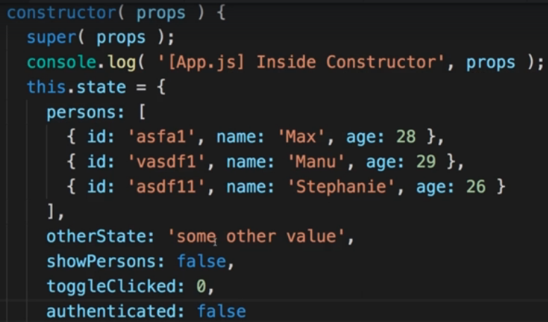  
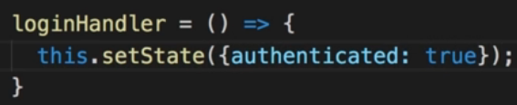  
=> Now let’s say we wanna change something in our Person component whenever this is set to true.  
=> We can of course try to pass our state down to persons, we can on the persons array set a property.  
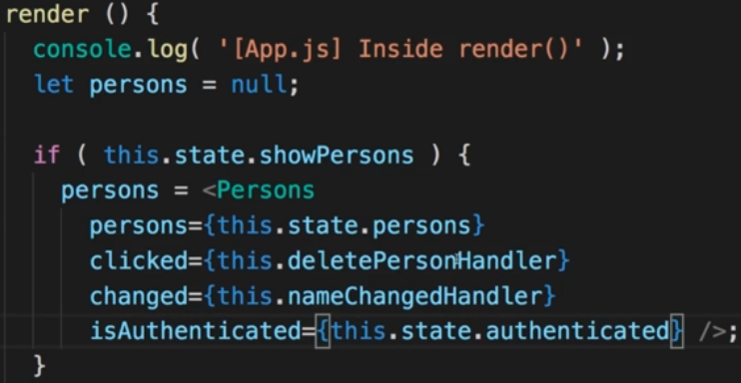  
=> In Persons.js.  
=> We can pass is down to the Person component.

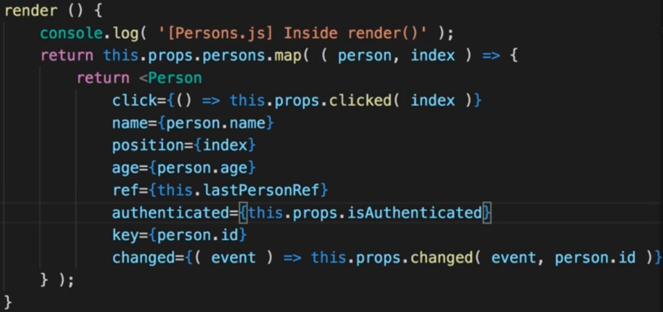  
=> And then in Person.js we can output some text if we are authenticated.  
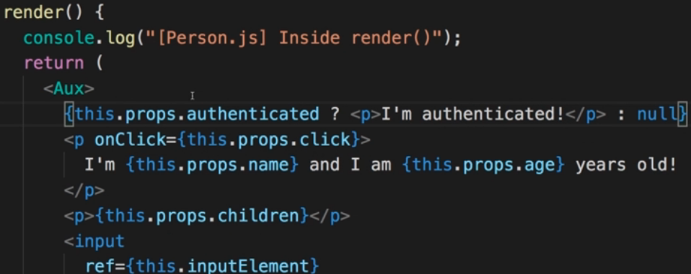  
=> So this is working, we’re passing data around.  
=> Now this is the default way of passing data around and it’s the recommended way for most use cases. However, you sometimes have some global state. Like the authentication status or for example regarding a global theme color set up by the user. Things like that.  
=> Now passing down the values is certainly an option but you can use the new **Context** **API** to make this a bit easier.  
=> In App.js we create the Context.  
  
=> We use it in our JSX code and **Context** in general works with **providers** and **consumers**.  
=> We got parts in our app where we provide the context and others where we consume it.  
=> In the App.js file this is where we provide it because here we manage the authentication status.  
=> So now we’re wrapping all components where we plan on extracting that value from the context - with a special component - named based on the name of the context we created earlier. So React.createContext() creates a component.   
=> We access **.Provider**, a sub-component created by React.  
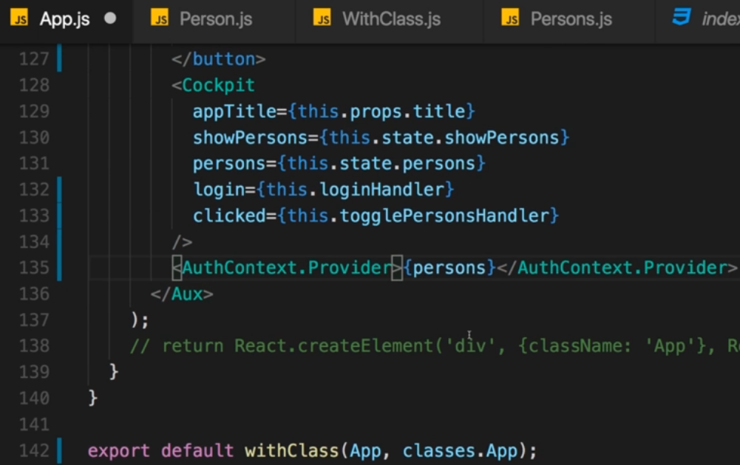  
=> Another important building blog is the value.   
=> Now we got that initial value of false because we initialized the context with false. But if you want to have a dynamic value which also can change, we add the value property (it has to be named value) to that provider component and we set it to the value we wanna use and this value can of course change.  
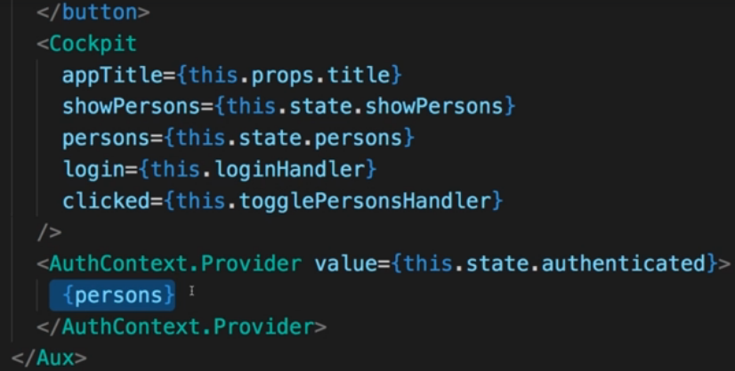  
=> So now we’re providing this context to all child components in there, no matter on which level they are. This is just one here but this could of course be more. And this one component actually hold more than one component.  
=> So in the Persons.js we can now get rid of that authenticated prop, also where we’re passing it to Persons in App.js we can remove it.  
=> Now in Person.js this is where we want to use out context.  
=> **We want to be able to import it so we add `export` in front of our AuthContext**. This makes it available outside of this file too.  
  
  
=> And now we need to wrap the element where we wanna use that context value.  
=> Now we use **.Consumer**, because we’ll now consume that value stored in the context.  
=> Now in this Consumer Component we still use {} but there we need to execute a method, which React will execute for us.  
=> This method receives one argument and this is the data we’re passing down with the context, this could of course be an object - in our case it’s a boolean.  
=> So here it’s our auth state and we return the JSX we wanna render.  
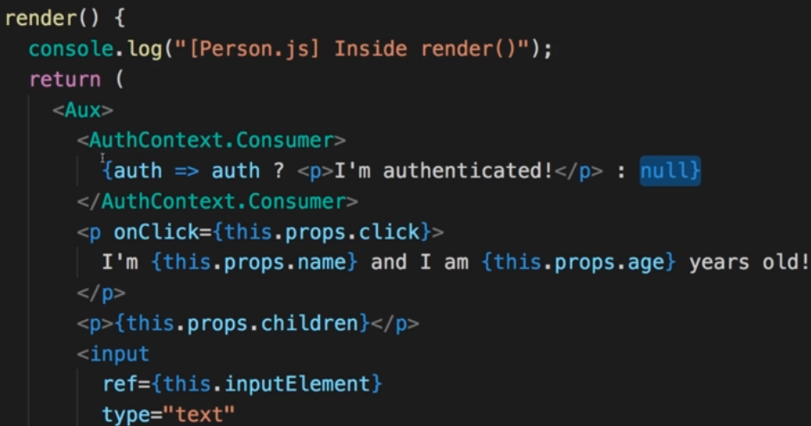  
=> Now we can pass data around without having to set up this chain of props.  
=> Still, the PROPS approach is recommended for most cases, it makes your components more reusable and doesn’t tie them together that much.  
* However, the Context API is really great for global settings like this one.  
**Updated Lifecycle Hooks (React 16.3)**  
* React 16.3 discourages the usage of 3 of them and adds 2 new ones.  
=> **AVOID: componentWillMount(), componentWillUpdate(), componentWillReceiveProps()**.   
=> They are discourages because they often were used incorrectly. You could call setState in there, you could do bad things in there. They’re not that useful and they’re easy to use incorrectly.  
=> React offers 2 new ones though.  
* **getDerivedStateFromProps(nextProps, prevState)**  
=> Now this Lifecycle Hook is executed whenever your props are updated and it gives you a chance of updating your state amongst with them. Now often you don’t want this.Your state should rarely be coupled to your props. These should be 2 independent things. But sometimes you got cases where you receive new props and you wanna update your local state because maybe you wanna work with that state, you wanna change it in that component before user clicks a save button and you commit it up the component tree in your app and therefore you change it somewhere else and therefore you would change your props again.  
=> You should return a new state so this can be object which will be merged with the old state, just like setState calls do it but you can also of course return the old state in which case you’ll never updating because you’ll always take the last one.  
=> But you could take the props, do something with them and return a new state object which would be used instead.  
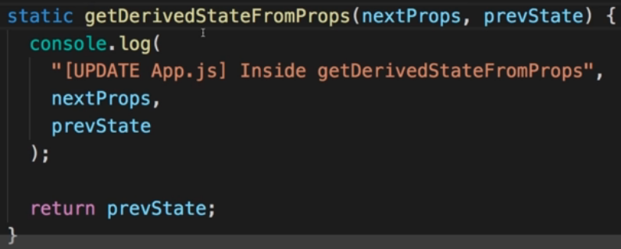  
=> 1 thing to make this work is: we actually have to use this `**static**` keyword in front of this method because it’s a static method, so basically a method which is not attached to a single instance.  
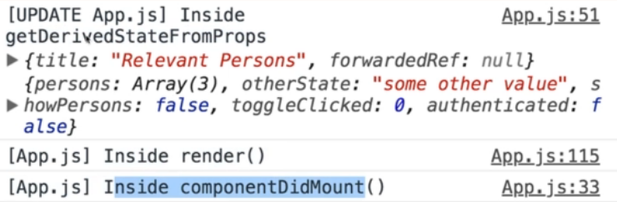  
=> It’s called before it’s actually rendering this and before it’s mounting this. It gives us a chance of updating our state right before it does these steps. And it will re-execute this whenever our props change.  
=> Not something you should overuse but **definitely nice if you’ve got a component that needs to bring state and props in sync**.  
* The second Lifecycle Hook is:  
getSnapshotBeforeUpdate()  
=> Now this allows you to get a snapshot of your DOM right before it’s about to change. So if you got some change in your component which need to change the DOM, this Lifecycle Hook will be executed right before the DOM does update.  
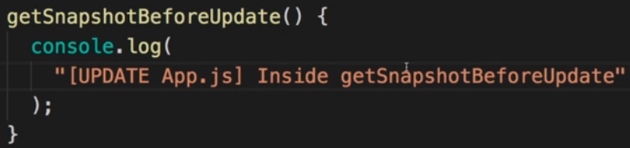  
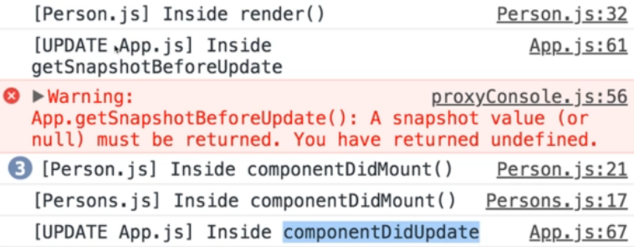  
=> This executes right before componentDidUpdate is done for the App.js component.  
=> So this is a great place to for example save the current scrolling position of your user. This can be very useful because in getSnapshotBeforeUpdate you can save it before the DOM changes and in componentDidUpdate you could scroll the user back to the previously saved position for example. Let’s say you have a list of items, you add new list items, here you can save the scrolling positions before they are added and here in componentDidUpdate you can set the user scrolling to that position after they have been added.  
=> This also is the exact example you see in the official docs, in the official log post of that new version.  
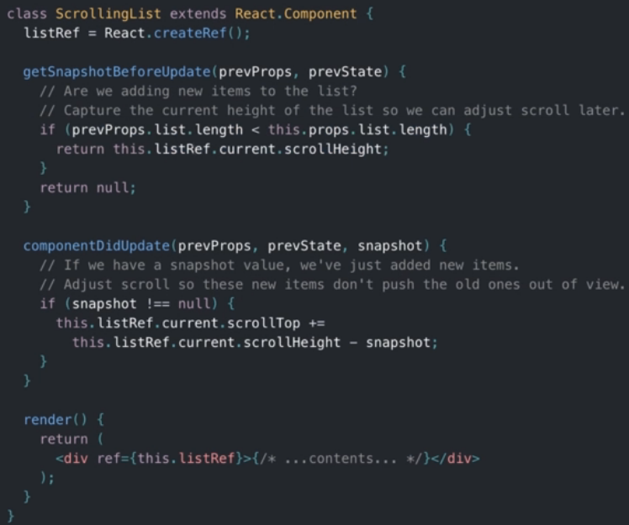  
* Don’t be afraid of seeing all these concepts, you might not use them all, you might only use a few of them, but you get better and better the more you learn about that and the more you question the approaches you use. Maybe there are some advanced concepts you may use - like a well-placed High Order Component (HOC) or a PureComponent.  
* In the upcoming project you should get a feeling for when to use what.  
**Resources:**  
State & Lifecycle: <https://reactjs.org/docs/state-and-lifecycle.html>   
PropTypes: <https://reactjs.org/docs/typechecking-with-proptypes.html>   
Higher Order Components: <https://reactjs.org/docs/higher-order-components.html>   
Refs: <https://reactjs.org/docs/refs-and-the-dom.html>

componentWillUnmount()

Section 7, Lecture 85

We saw the Component Lifecycle during Component Creation in Action.

There also is one Lifecycle method which gets executed (when implemented) **right before** a Component is **removed** from the DOM: componentWillUnmount() .

*Here's an Example:*

**App.js** (using class App extends Component )

1. state = {
2. showUserComponent: true
3. };
5. removeUserHandler = () => {
6. this.setState({showUserComponent: false});
7. }
9. render() {
10. return (
11. <div>
12. {this.state.showUserComponent ? <User /> : null}
13. <button onClick={this.removeUserHandler}>Remove User Component</button>
14. </div>
15. );
16. }

**User.js** (using class User extends Component )

1. componentWillUnmount() {
2. // Component is about to get removed => Perform any cleanup work here!
3. console.log('I\'m about to be removed!');
4. }

In the above example, the User component is removed upon a button click (due to it being rendered conditionally and the condition result being changed to false ). This triggers componentWillUnmount()  to run in the User component right before the component is destroyed and removed from the DOM.

React 16.2 Feature: Fragments

Section 7, Lecture 93

If your project uses **React 16.2**, you can now use a built-in "Aux" component - a so called **fragment**.

It's actually not called Aux  but you simply use <>  - an empty JSX tag.

So the following code

1. <Aux>
2. <h1>First Element</h1>
3. <h1>Second Element</h1>
4. </Aux>

becomes

1. <>
2. <h1>First Element</h1>
3. <h1>Second Element</h1>
4. </>

As per the [documentation](https://reactjs.org/docs/fragments.html#short-syntax), the syntax <></> is not supported by all tools and they encourage you to use <React.Fragment> instead

Check [**this**](https://reactjs.org/blog/2017/11/28/react-v16.2.0-fragment-support.html#support-for-fragment-syntax) documentation on Support for Fragment syntax

Behind the scenes, it does the same our Aux  component did.

**On Windows**, the Aux.js  filename is not allowed in ZIP archives. Hence when extracting the attached source code, you might get prompted to rename the Aux.js  file. You might also **face difficulties creating an Aux folder** and Aux.js file.

I really apologize for that inconvenience, Windows is really doing an amazing job here ;-).

Follow these fixes:

**1) Problems when unzipping the attached file:**

Simply **skip this step** (e.g. by pressing **"No"**) and **ignore** the upcoming error message.

In the extracted folder, you'll then find **all source files** EXCEPT for the Aux.js  file. In later course modules (where we work on the course project), the Aux.js  file can be found in an Aux/  subfolder inside hoc/ .

Make sure to take the Aux.js  file **attached to this lecture** and place it inside the hoc/  or hoc/Aux/  folder (which ever of the two you got).

**2) Problems with the creation of an Aux folder and/ or file:**

Simply name both differently. For example, you may create an Auxiliary  folder and name the file inside of it Auxiliary.js . Make sure to then adjust your imports (import Aux from './path/to/Auxiliary/Auxiliary' ) and you should be fine.

Source: <https://reactjs.org/docs/typechecking-with-proptypes.html>

1. import PropTypes from 'prop-types';
3. MyComponent.propTypes = {
4. // You can declare that a prop is a specific JS primitive. By default, these
5. // are all optional.
6. optionalArray: PropTypes.array,
7. optionalBool: PropTypes.bool,
8. optionalFunc: PropTypes.func,
9. optionalNumber: PropTypes.number,
10. optionalObject: PropTypes.object,
11. optionalString: PropTypes.string,
12. optionalSymbol: PropTypes.symbol,
14. // Anything that can be rendered: numbers, strings, elements or an array
15. // (or fragment) containing these types.
16. optionalNode: PropTypes.node,
18. // A React element.
19. optionalElement: PropTypes.element,
21. // You can also declare that a prop is an instance of a class. This uses
22. // JS's instanceof operator.
23. optionalMessage: PropTypes.instanceOf(Message),
25. // You can ensure that your prop is limited to specific values by treating
26. // it as an enum.
27. optionalEnum: PropTypes.oneOf(['News', 'Photos']),
29. // An object that could be one of many types
30. optionalUnion: PropTypes.oneOfType([
31. PropTypes.string,
32. PropTypes.number,
33. PropTypes.instanceOf(Message)
34. ]),
36. // An array of a certain type
37. optionalArrayOf: PropTypes.arrayOf(PropTypes.number),
39. // An object with property values of a certain type
40. optionalObjectOf: PropTypes.objectOf(PropTypes.number),
42. // An object taking on a particular shape
43. optionalObjectWithShape: PropTypes.shape({
44. color: PropTypes.string,
45. fontSize: PropTypes.number
46. }),
48. // You can chain any of the above with `isRequired` to make sure a warning
49. // is shown if the prop isn't provided.
50. requiredFunc: PropTypes.func.isRequired,
52. // A value of any data type
53. requiredAny: PropTypes.any.isRequired,
55. // You can also specify a custom validator. It should return an Error
56. // object if the validation fails. Don't `console.warn` or throw, as this
57. // won't work inside `oneOfType`.
58. customProp: function(props, propName, componentName) {
59. if (!/matchme/.test(props[propName])) {
60. return new Error(
61. 'Invalid prop `' + propName + '` supplied to' +
62. ' `' + componentName + '`. Validation failed.'
63. );
64. }
65. },
67. // You can also supply a custom validator to `arrayOf` and `objectOf`.
68. // It should return an Error object if the validation fails. The validator
69. // will be called for each key in the array or object. The first two
70. // arguments of the validator are the array or object itself, and the
71. // current item's key.
72. customArrayProp: PropTypes.arrayOf(function(propValue, key, componentName, location, propFullName) {
73. if (!/matchme/.test(propValue[key])) {
74. return new Error(
75. 'Invalid prop `' + propFullName + '` supplied to' +
76. ' `' + componentName + '`. Validation failed.'
77. );
78. }
79. })
80. };

#### Requiring Single Child

With PropTypes.element you can specify that only a single child can be passed to a component as children.

1. import PropTypes from 'prop-types';
3. class MyComponent extends React.Component {
4. render() {
5. // This must be exactly one element or it will warn.
6. const children = this.props.children;
7. return (
8. <div>
9. {children}
10. </div>
11. );
12. }
13. }
15. MyComponent.propTypes = {
16. children: PropTypes.element.isRequired
17. };

Default Prop Values

You can define default values for your props by assigning to the special defaultProps property:

1. class Greeting extends React.Component {
2. render() {
3. return (
4. <h1>Hello, {this.props.name}</h1>
5. );
6. }
7. }
9. // Specifies the default values for props:
10. Greeting.defaultProps = {
11. name: 'Stranger'
12. };
14. // Renders "Hello, Stranger":
15. ReactDOM.render(
16. <Greeting />,
17. document.getElementById('example')
18. );

The defaultProps will be used to ensure that this.props.name will have a value if it was not specified by the parent component. The propTypes typechecking happens after defaultProps are resolved, so typechecking will also apply to the defaultProps.